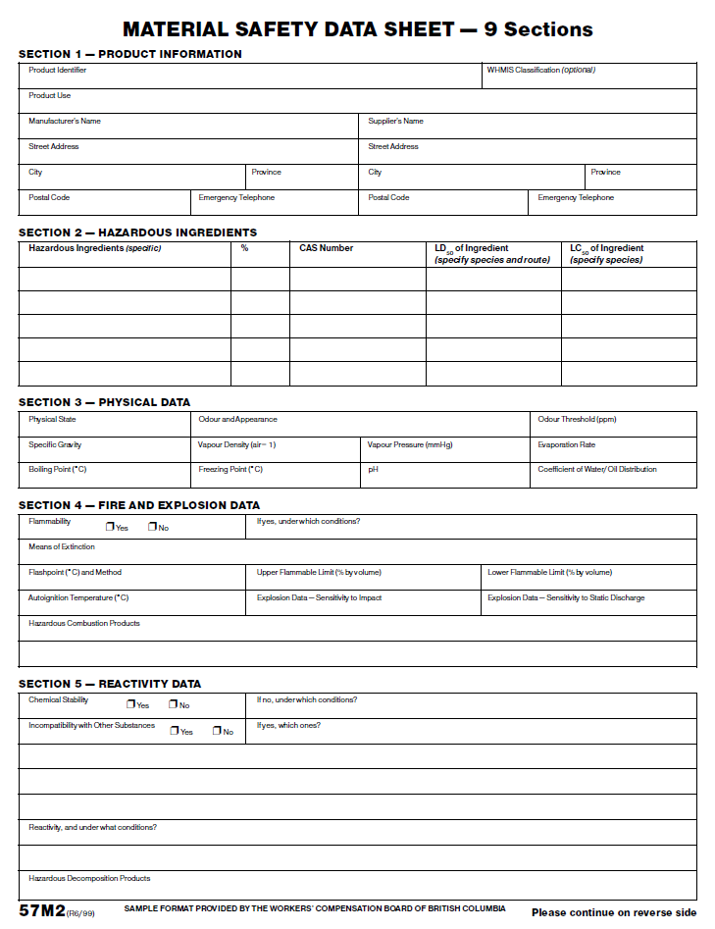

Sample Material Safety Data Sheet (Used with permission of WorkSafeBC)

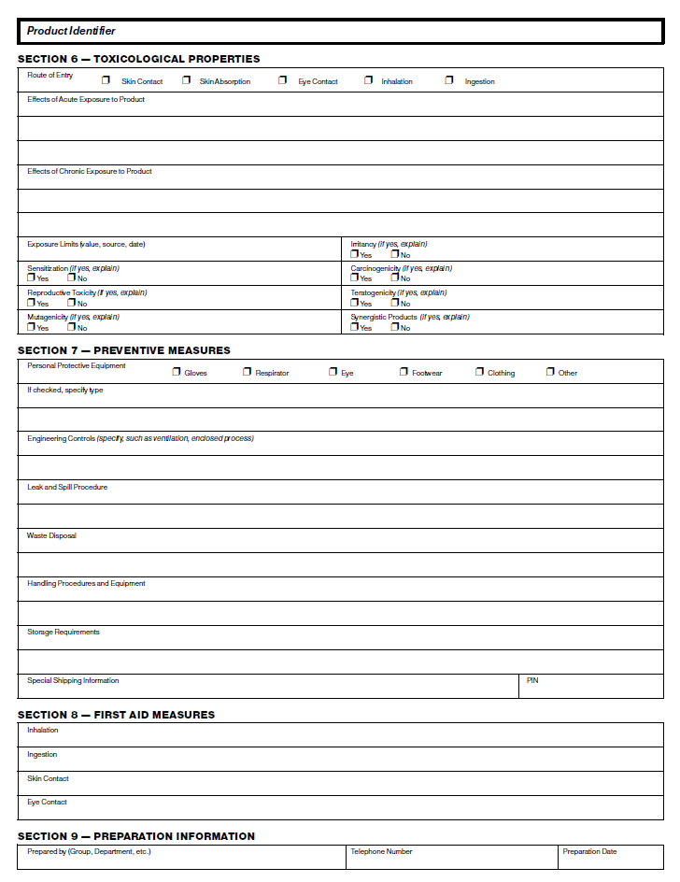

Sample Material Safety Data Sheet (Used with permission of WorkSafeBC)

