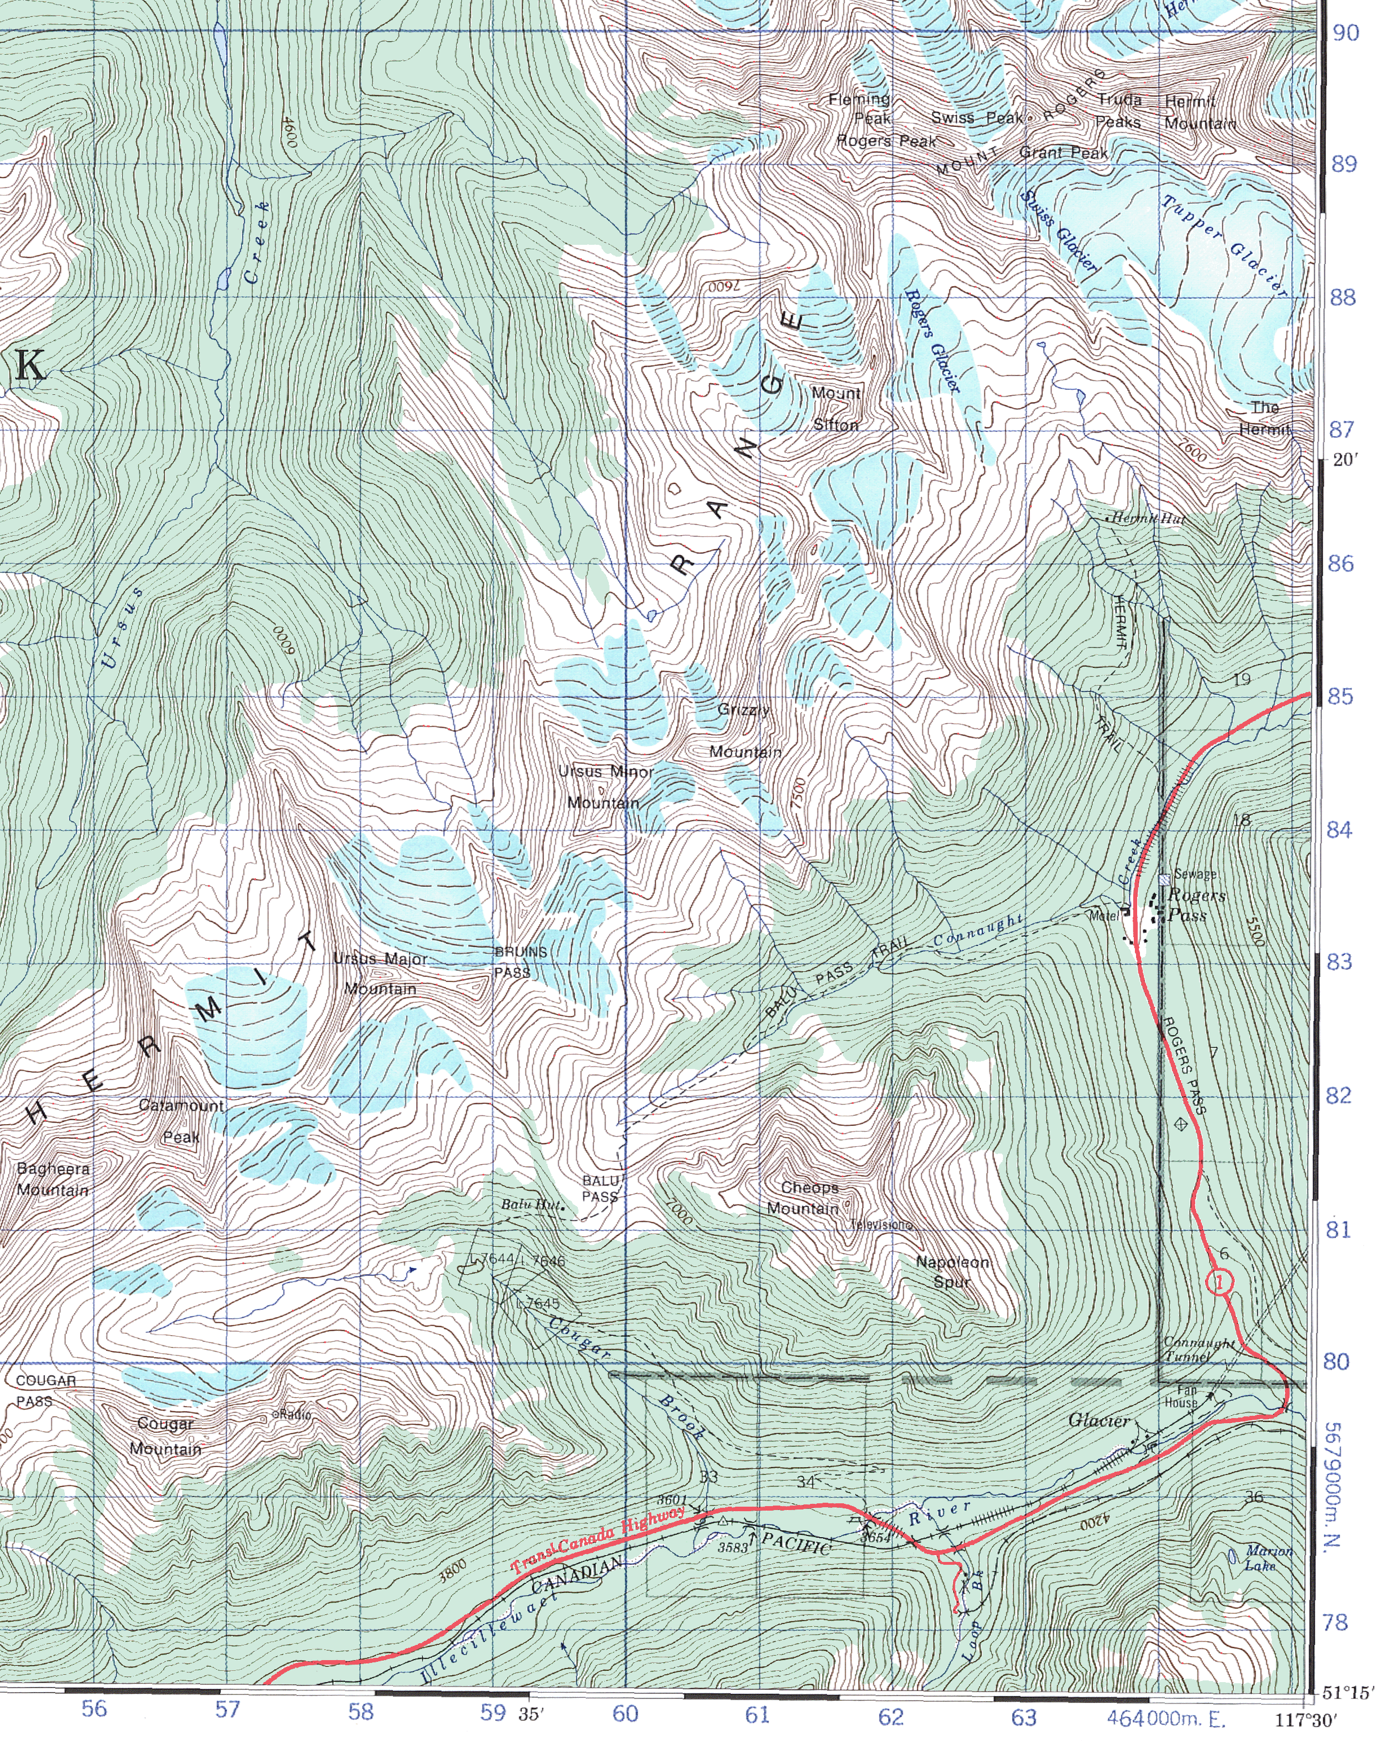
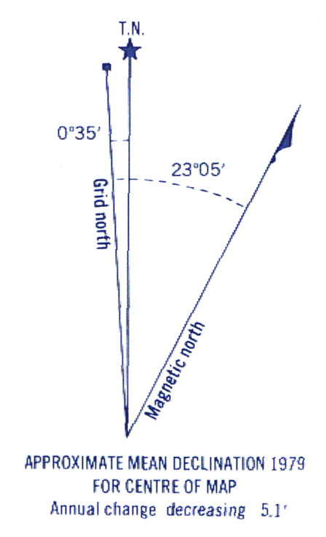

Figure 15.5. Part of NTS 1:50,000 map sheet 82N05 (Glacier) 3rd edition. Elevation units are in feet.

