Le Français Interactif

– An Activity Companion Site Style Sheet
Last revised: March 22nd, 2023
Editor: Harper Friedman
Author: Mirabelle Tinio
Textbook: Le Français Interactif – An Activity Companion Site

Book/Chapter Structure

Book
- Book is comprised of 6 chapters (Parts) 0 – 5. Has several sections (Chapters) within.

Chapter structure
- Chapter begins with Learning Objectives in Part page.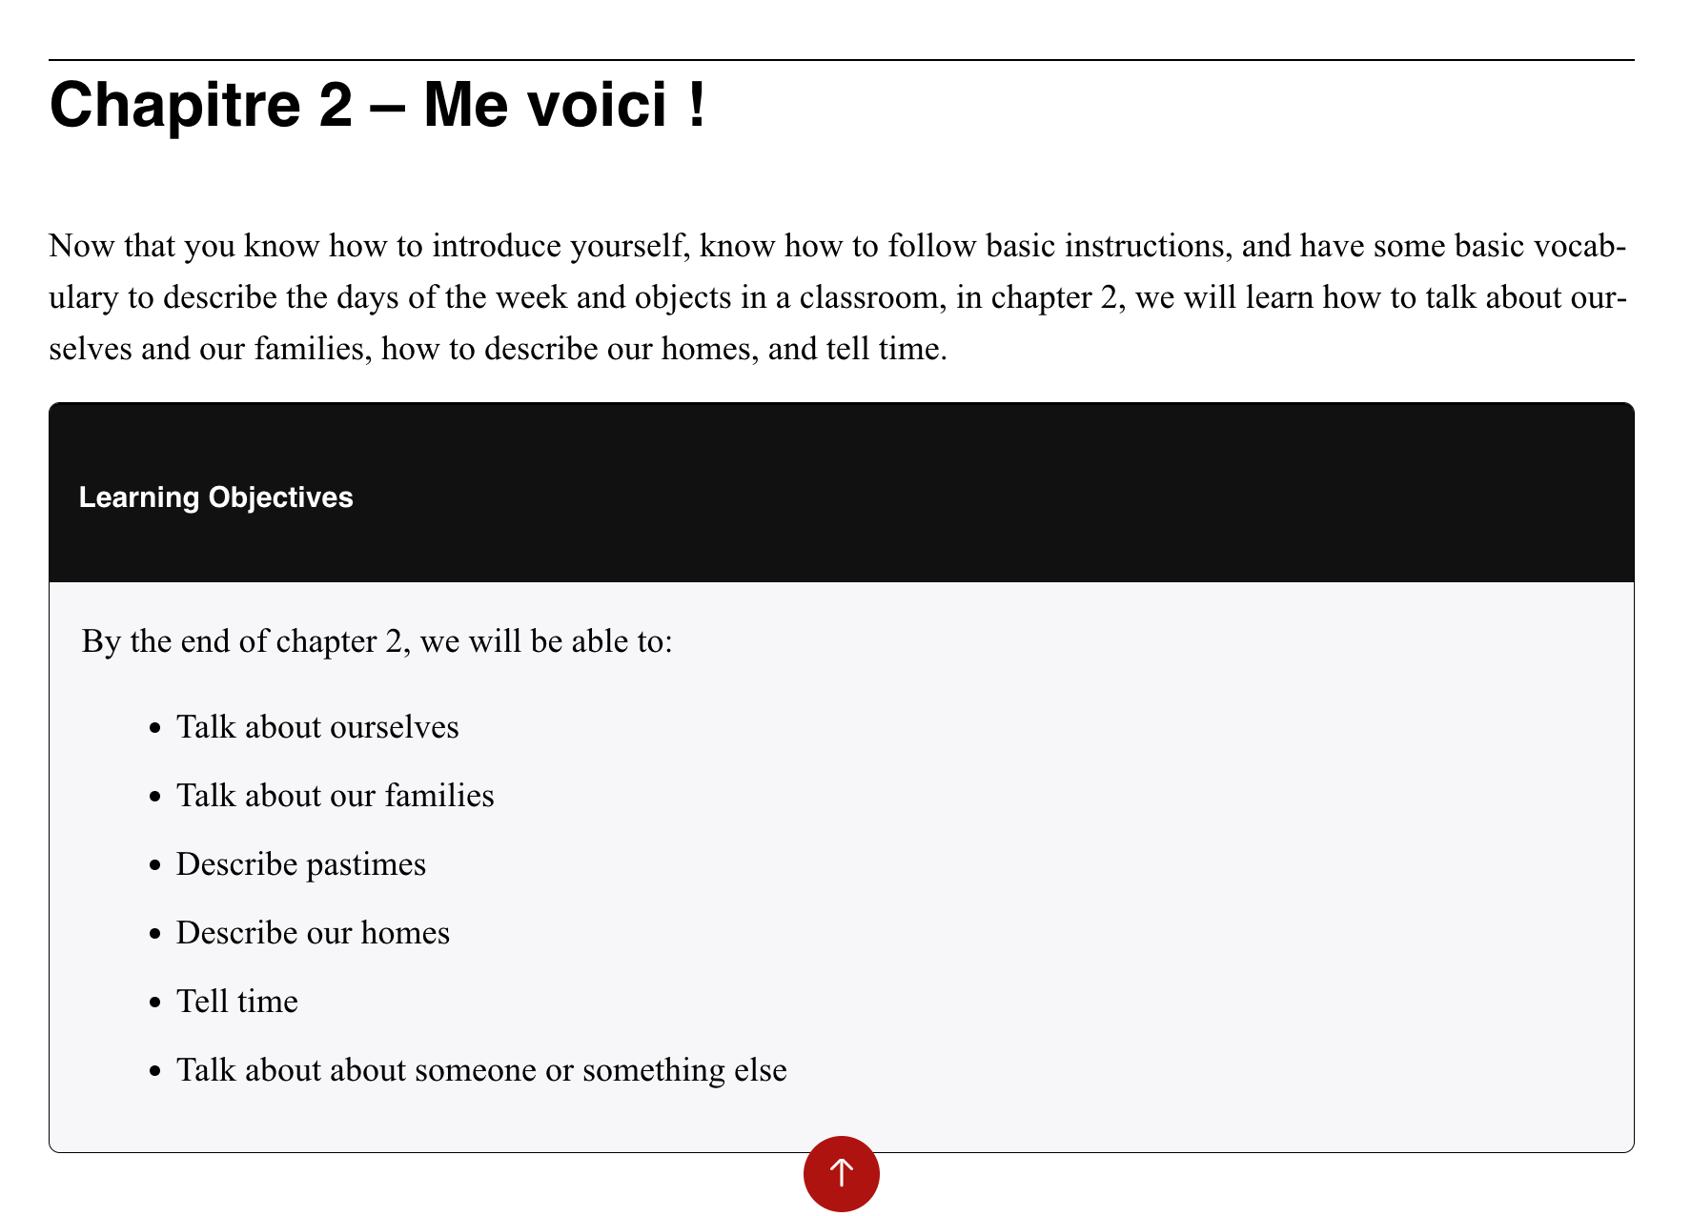
- Learning Contents Menu - Contenus d’apprentissage
- Questionnaire
- Vocabulaire
- Entraînement
- Compréhension orale
- Auto-évaluation
- Personal Goals Page
In Chapter 0 there is also:
- Faisons connaissance
- Basic greetings
- Test de personnalité
In Chapter 2 there is:
- Compréhension de lecture et compréhension orale
- Test de personnalité

Parts page
- Contains a blurb about the chapter
- Learning Objectives in black Learning Objectives textbox .
  - Header is “Learning Objectives” in Header 2
  - Text reads “By the end of chapter <#>, we will be able to:”
  - Followed by unordered list of items with Sentence case.
- Chapter 1 has a H5P exercise.

Learning Contents Menu - Contenus d’apprentissage
- Starts with “By the end of chapter <#>, we will be able to:”
- Followed by an unordered list of topics with links to chapters and exercises
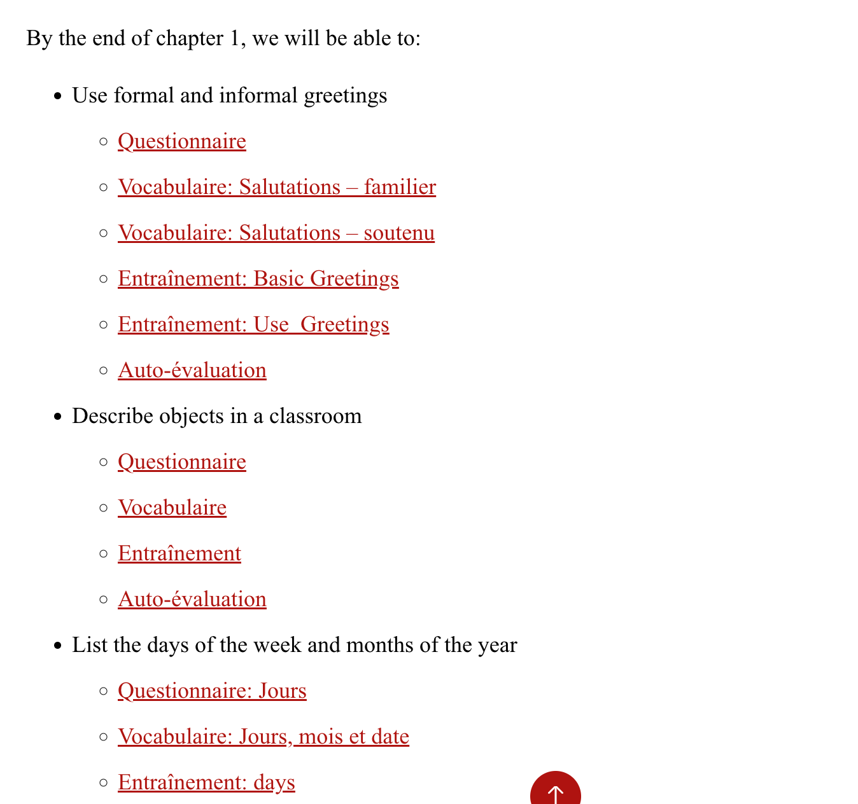
- Followed by H1 headers that contain more topics and links.
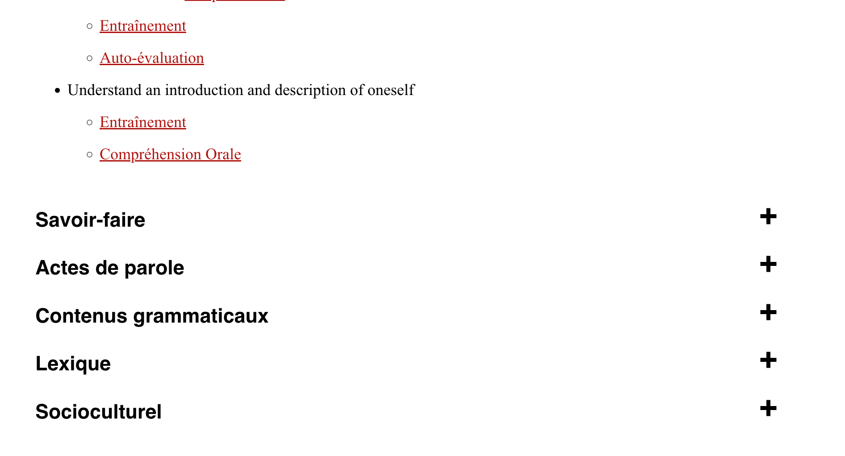
- The topics are in bold text.
- Words after colons ( : ) are capitalised.
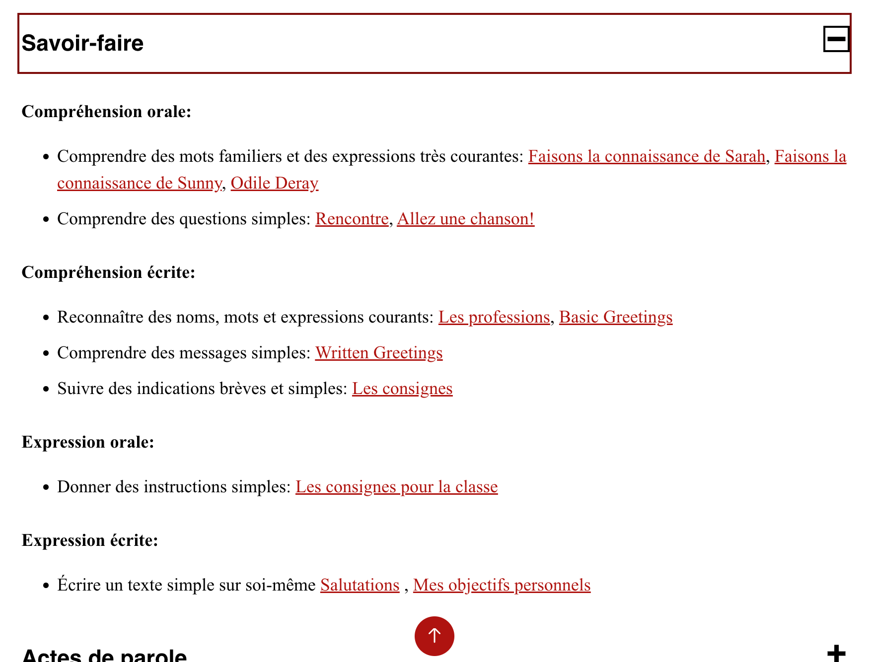

Questionnaire
- Begins with a blurb that is similar in each chapter, though not the same
- Followed by a green Key Terms textbox with a couple H5P activities
  - Title is “What do we know?” in H2 header style
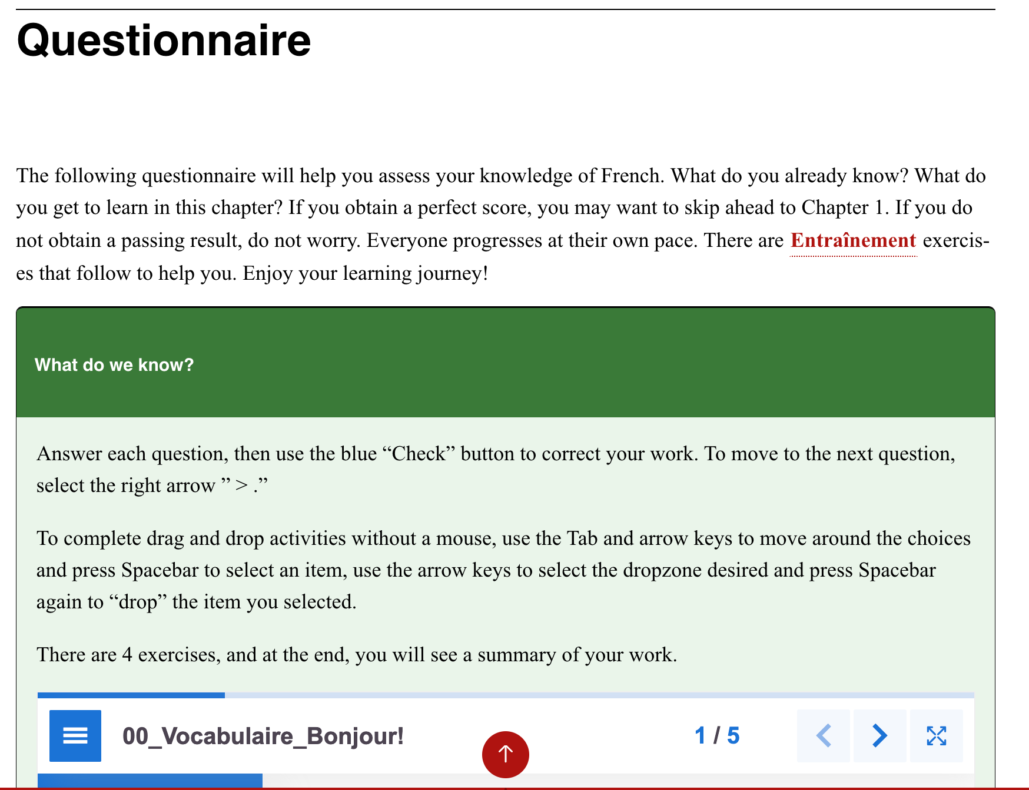

Vocabulaire
- Begins with a blurb
- Followed by black Learning Objectives textbox
  - Title is “Lexique”
  - Contains image on right
  - Contains unordered list of items in Sentence case

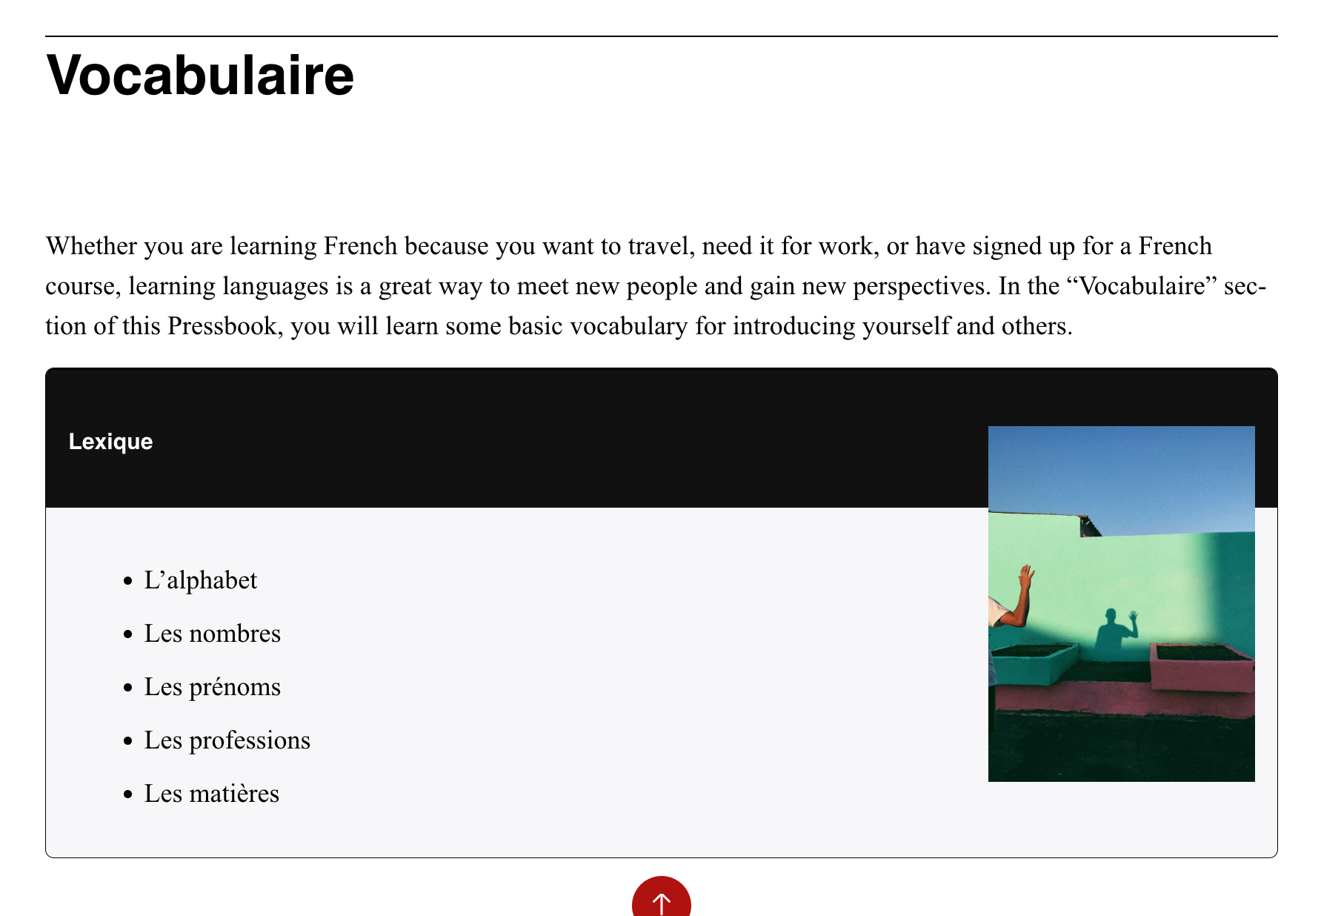
- Followed by H1 header sections, underneath have H5P activities (non-standardised)
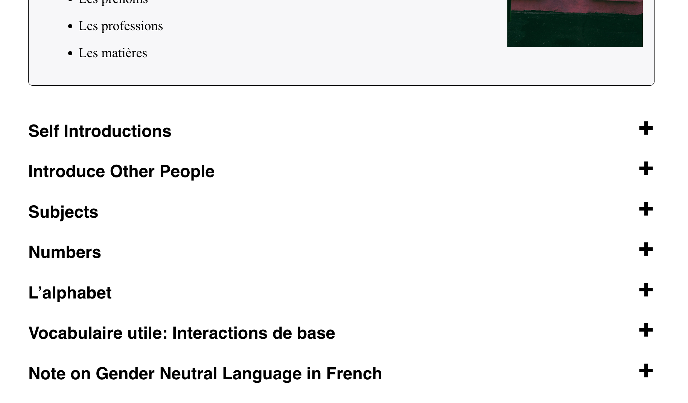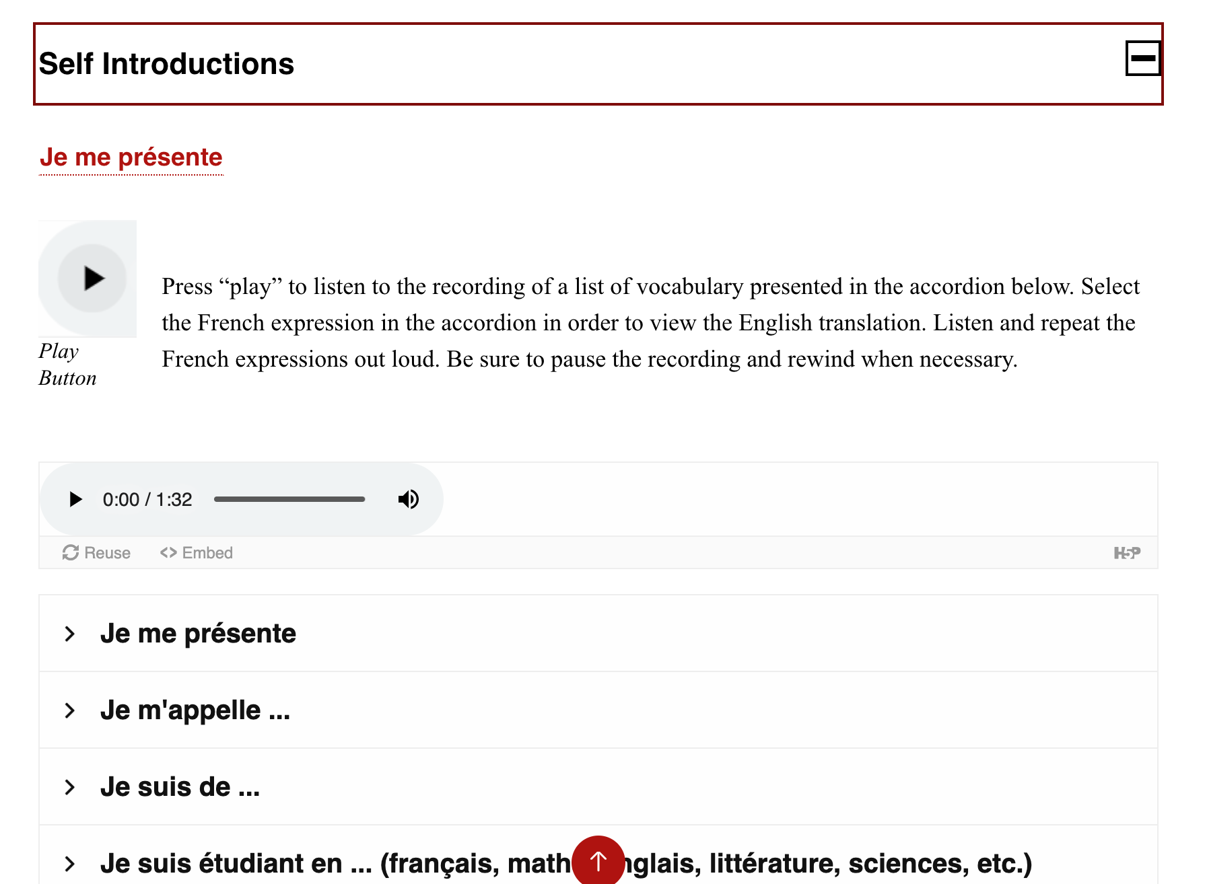

Entraînement
- Starts with blurb and image
- Followed by several H1 header sections (not standardised)
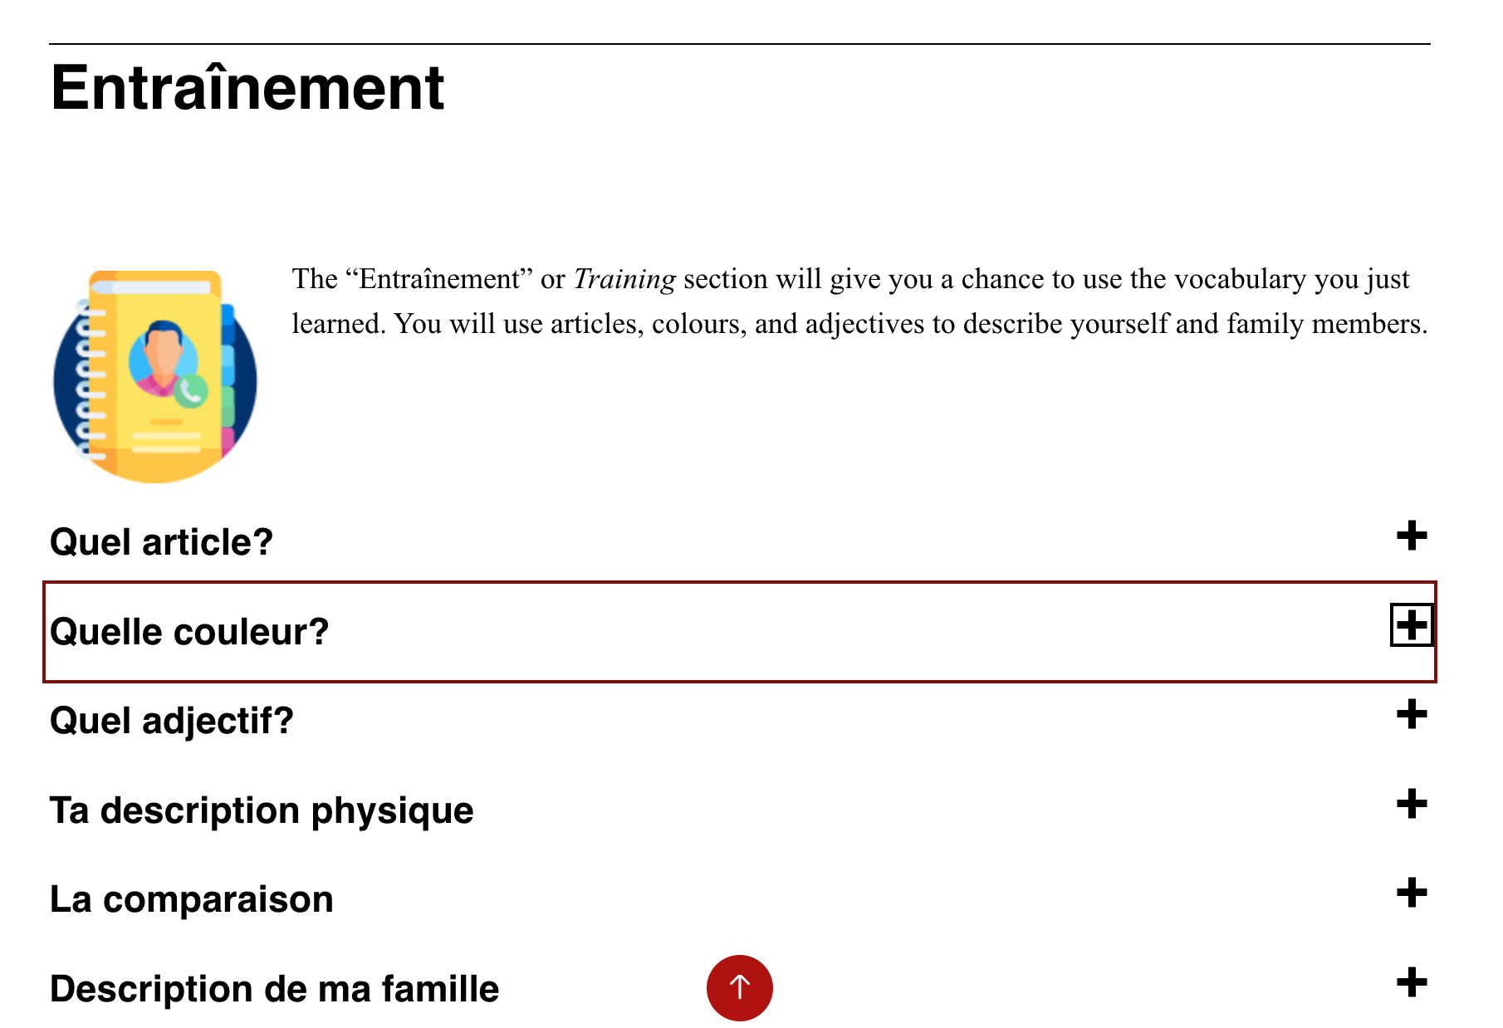

Compréhension orale
- Starts with blurb and image
- Followed by several H1 header sections (not standardised)
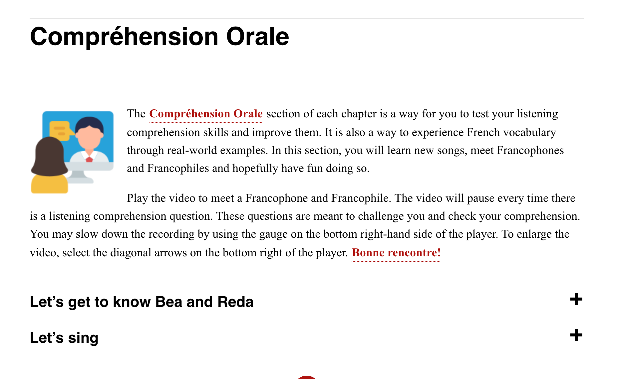

Auto-évaluation
- Starts with blurb and image
- Followed by tables, text, H5P exercises, and/or several H1 header sections (not standardised)

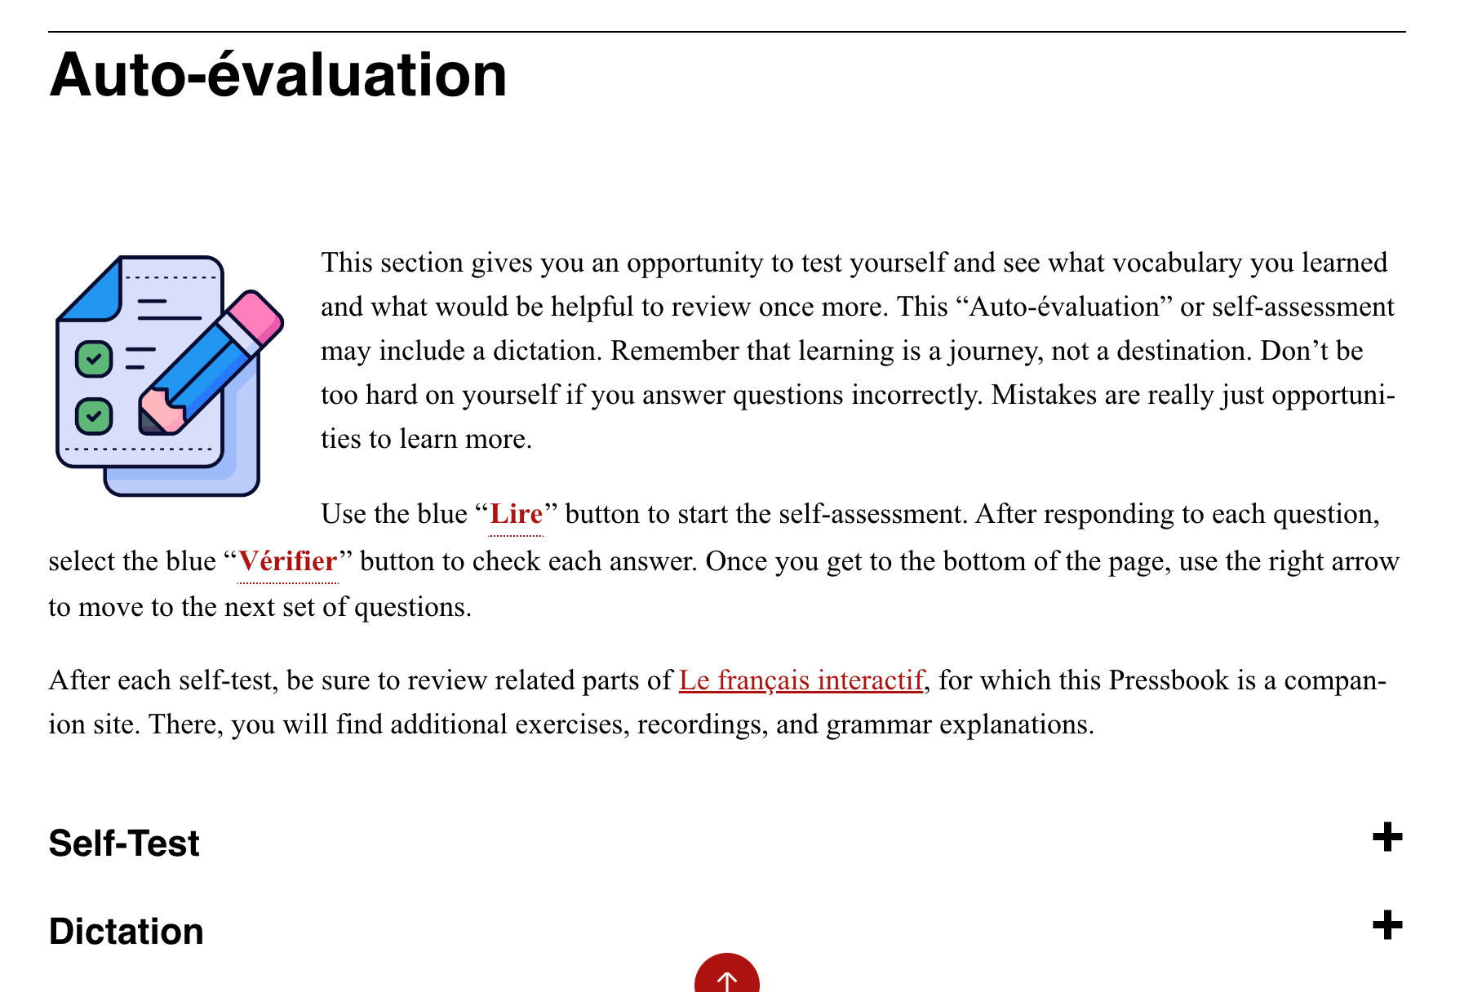

Personal Goals Page
- Contains green Key Terms page titled Mes Objectifs Personnels as a glossary term
- Followed by H5P exercise
