Style Sheet for Math for Trades – Volume 3
Authors: Mark Overgaard and Chad Flinn
Book link: Math 4 Trades: Volume 3
Book/Chapter Structure
- The book is broken up into Parts titled with the overlying topic and Chapters, which are subsections of the Part.
- The final Chapter within each Part is a Practice Quiz.
- Each part contains an image and a black textbox named “Outcomes”.
- Order of content within a chapter:
  - Audio version of the chapter’s content
  - Content interspersed with two red Example textboxes and a Practice Questions section containing two Question textboxes
- Book contains a Backmatter chapter called Appendix A: Offline Copies of Chapter Quizzes, which contains text versions of the H5P chapter quizzes.

Practice Quiz
- Each Practice Quiz chapter contains a H5P quiz.
- Below the H5P quiz, there is text that reads “If using the print, PDF, or eBook copy of this book, navigate to the above link to complete the quiz. However, the quiz questions are also provided in Appendix A at the end of the book for offline use.” with an internal link to Appendix A of the book.
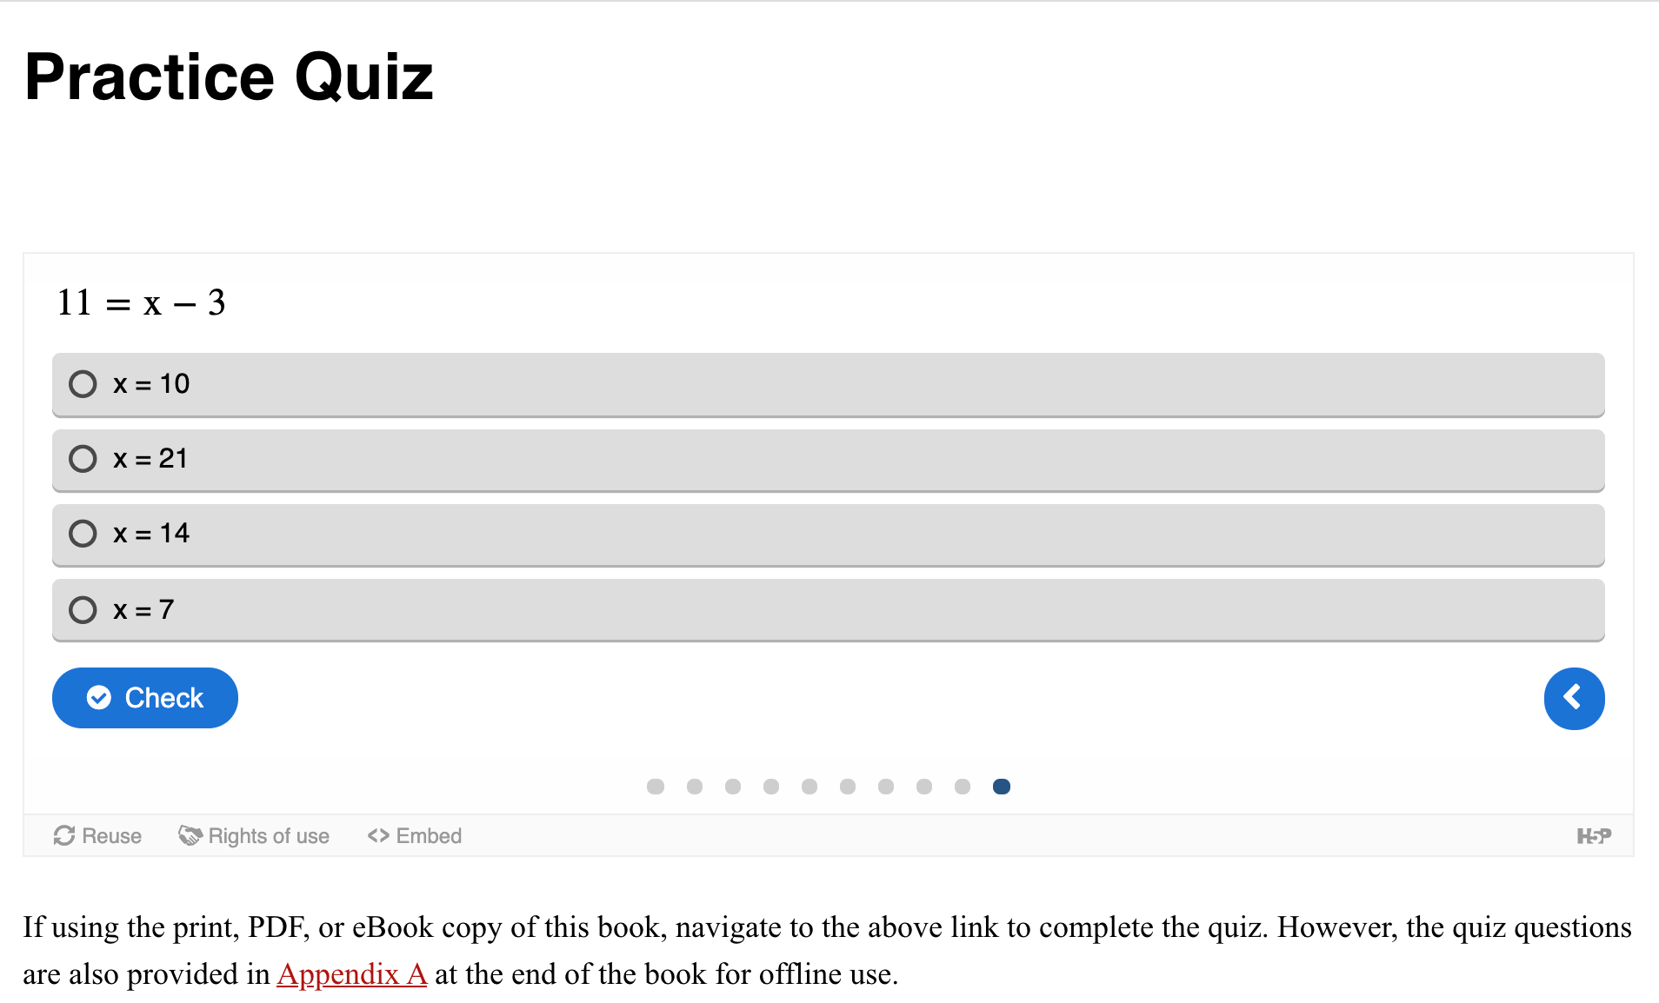

Appendix A
- Chapter titled “Appendix A: Offline Copies of Chapter Quizzes”
- Each quiz titled “Unit # Practice Quiz”
- Contains an ordered list of the questions in the practice quiz
- Followed by Answers under the heading “Answers”
- Answers contain an ordered list of the answers to the practice quiz questions
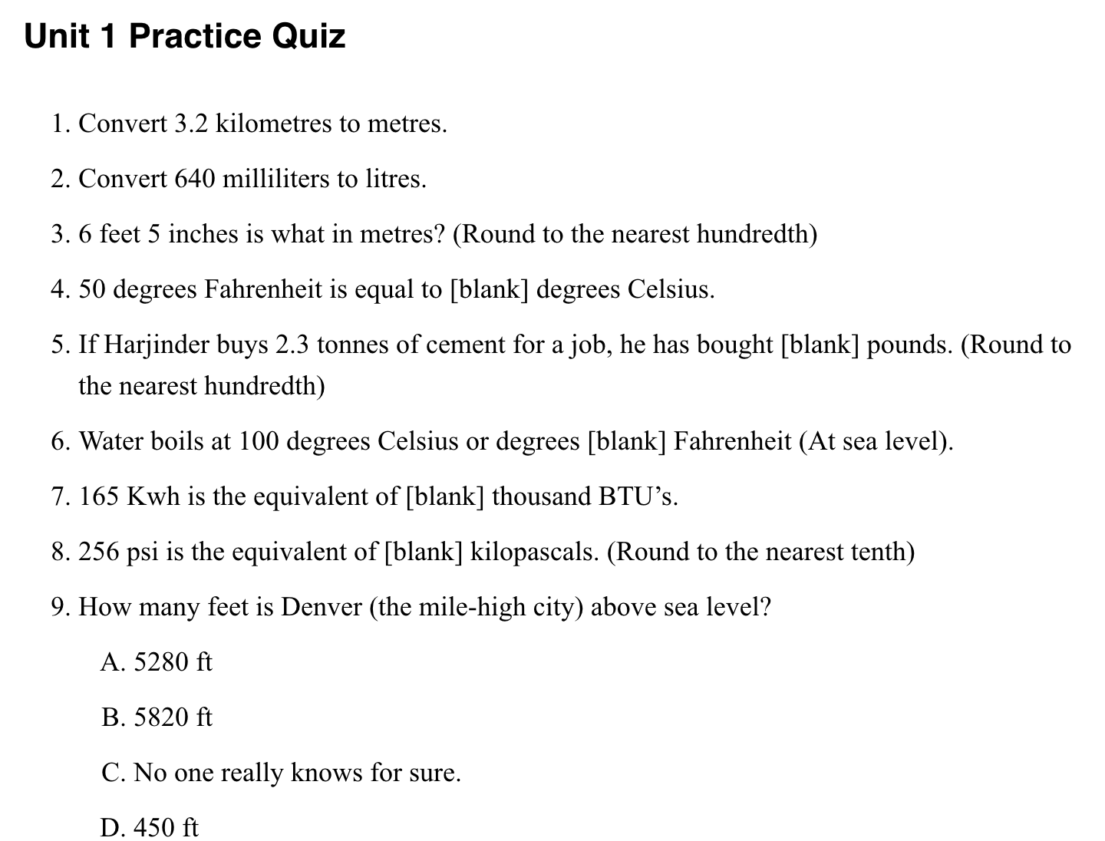

LaTeX
- Watch out for >/< symbols in LaTeX equations – either recreate the equation in plain text or take a screen shot and insert the image instead
- Use a hyphen to denote a negative sign in LaTeX equations (for example: \(-3x\)) rather than \text{−} (for example: \(\text{−}3x\))
- Use \cdot for a multiplication dot rather than • (for example: \(4 \cdot 5))

Tables
- All tables should have width=100%
- All tables should have a Standard class
- Header cells should be denoted as such (in the example below, they are Unit and Multiplier) using the Table’s Header Cell function and the proper scope should be applied (in the example below, the scope is Column).
- There should be no merged cells
- Any unnecessary columns or rows should be removed
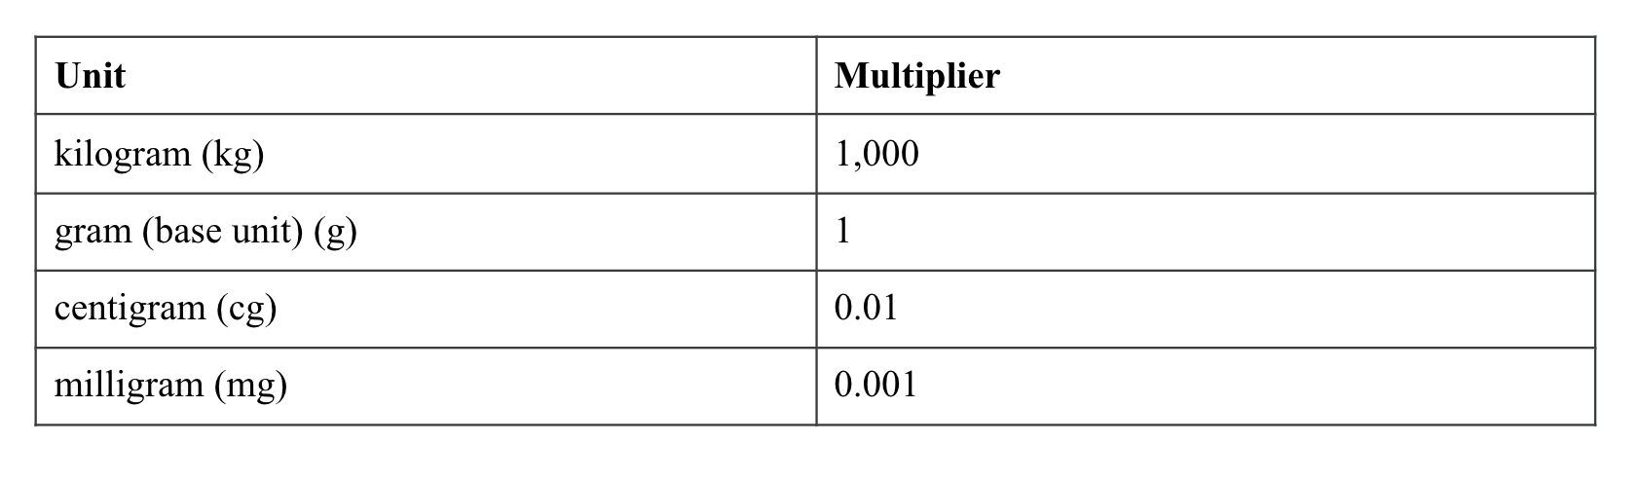

Titles and Headings

Chapter/Part Titles
- Part: Name of Part Section in Title Case
- Chapter: Name of Chapter Section in Title Case

Section Headings
- Section titles within a chapter all use H1, such as the examples below
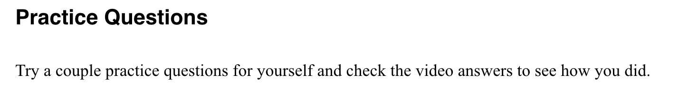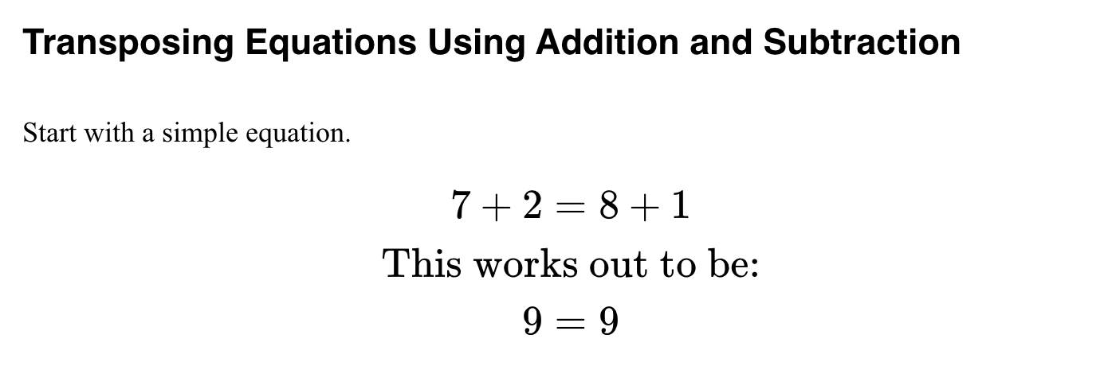

Appendix A
- Quiz name: “Unit # Practice Quiz” using H1
- Answers: “Answers” using H2

Textbox headings
- See “Textboxes” section.

Textboxes

OUTCOMES
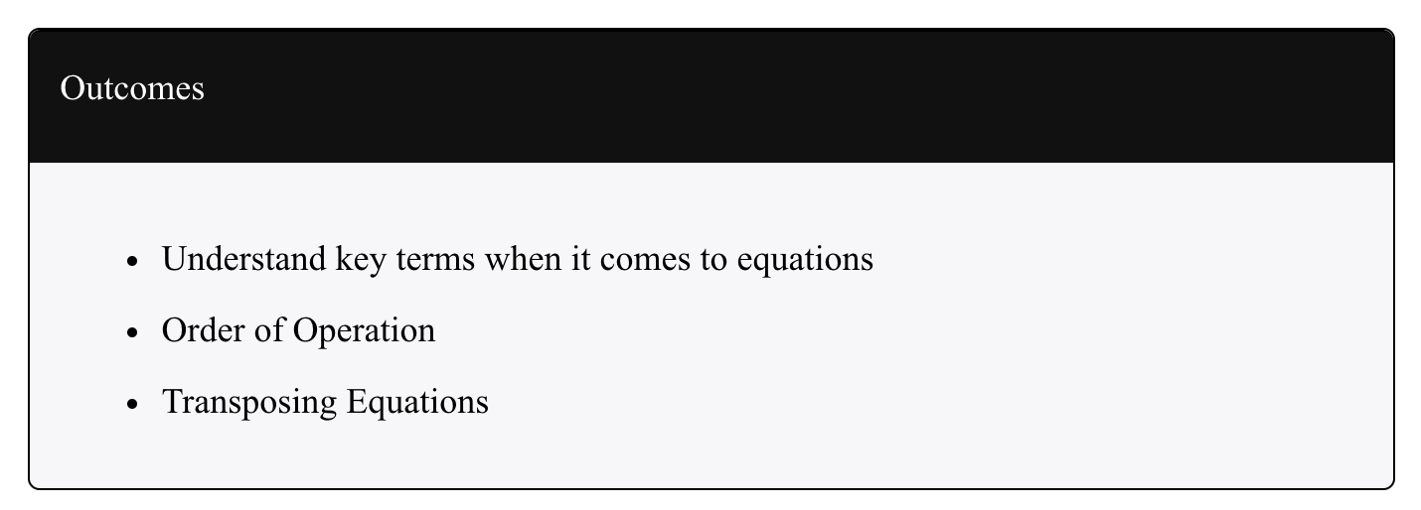
- There is an Outcomes textbox in every Part
- It uses the BLACK textbox
- Title: Outcomes
- Has an unordered list that starts with a capitalized word
- There is no period at the end of the list items

EXAMPLE
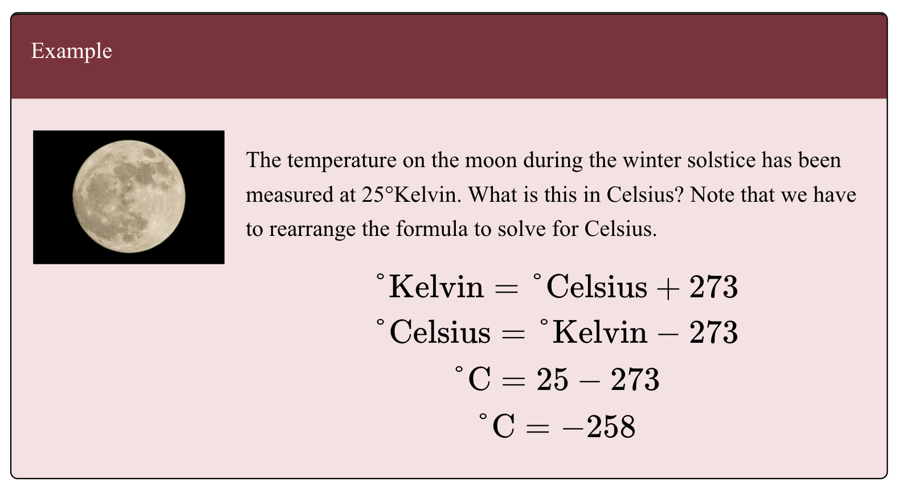
- It uses the RED textbox
- Title: Example
- Any decorative images in Example should be left-aligned

PRACTICE QUESTIONS
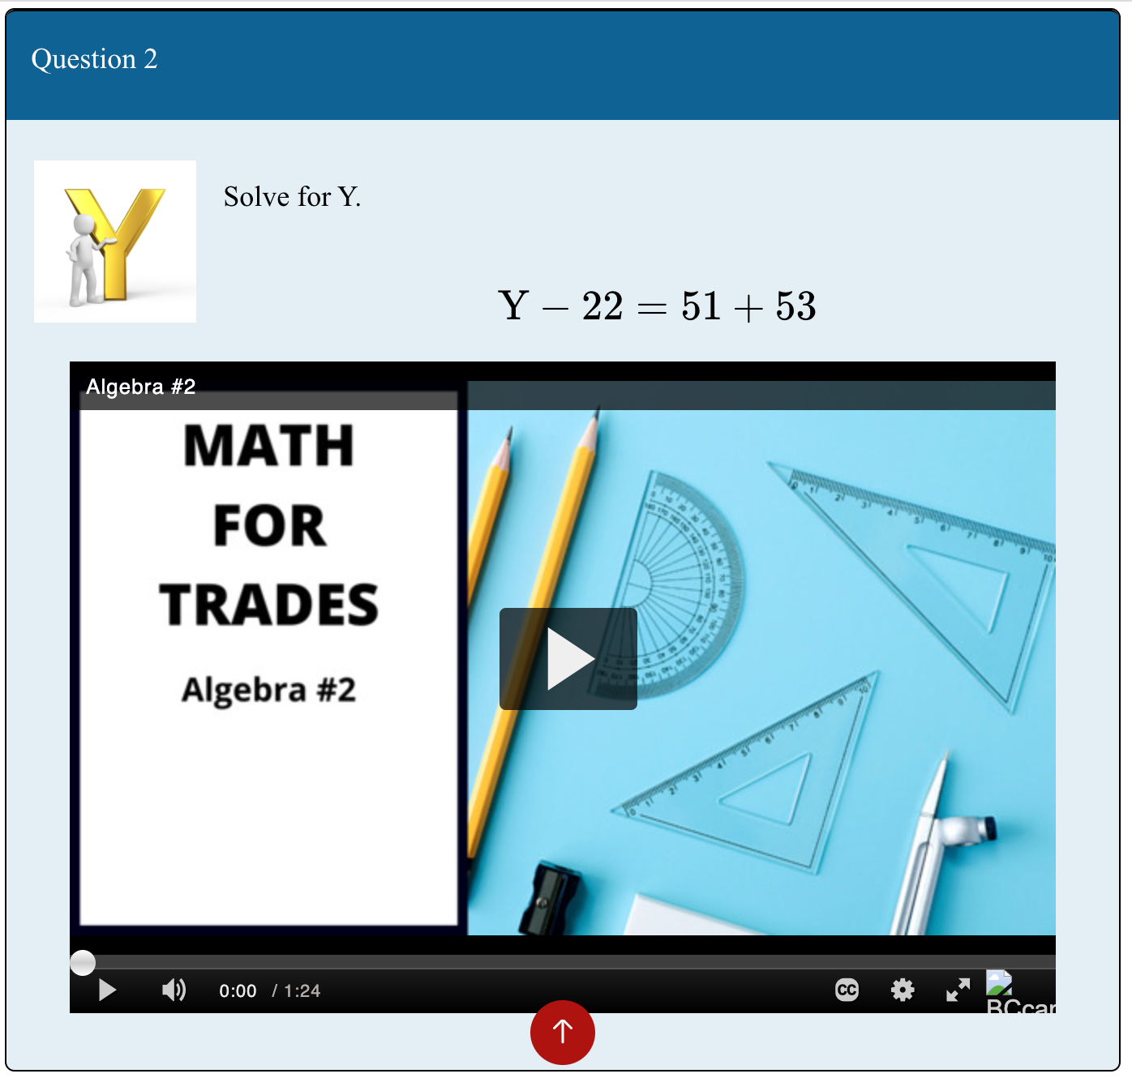
- It uses the Blue textbox
- Title: Question #
- Contains text for question along with the corresponding video that outlines the question and solution.
- Any decorative images in Questions should be left-aligned

Question and Answers
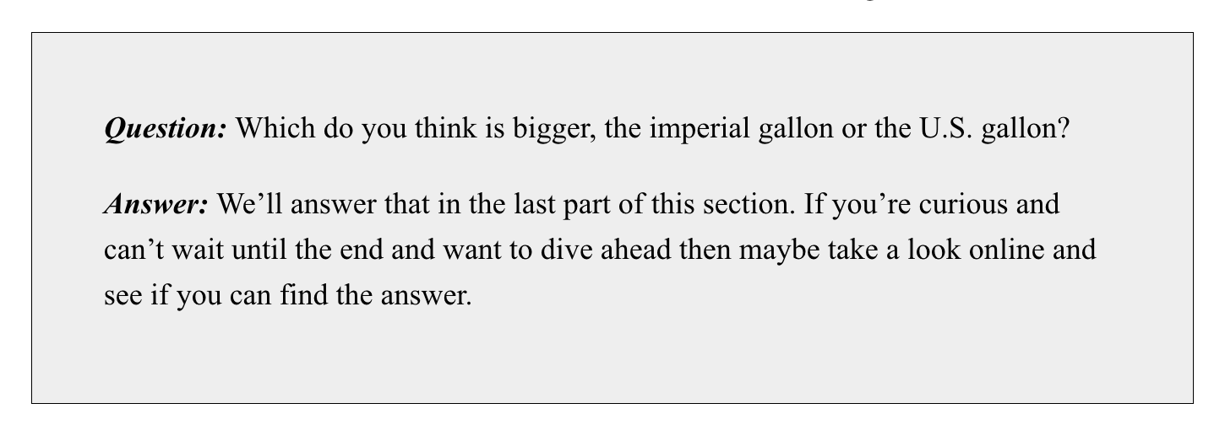
- In shaded textbox
- Text begins with Question: that is bolded and italic.
- Second line is Answer: that is bolded and italic
- Text is in paragraph style

Images
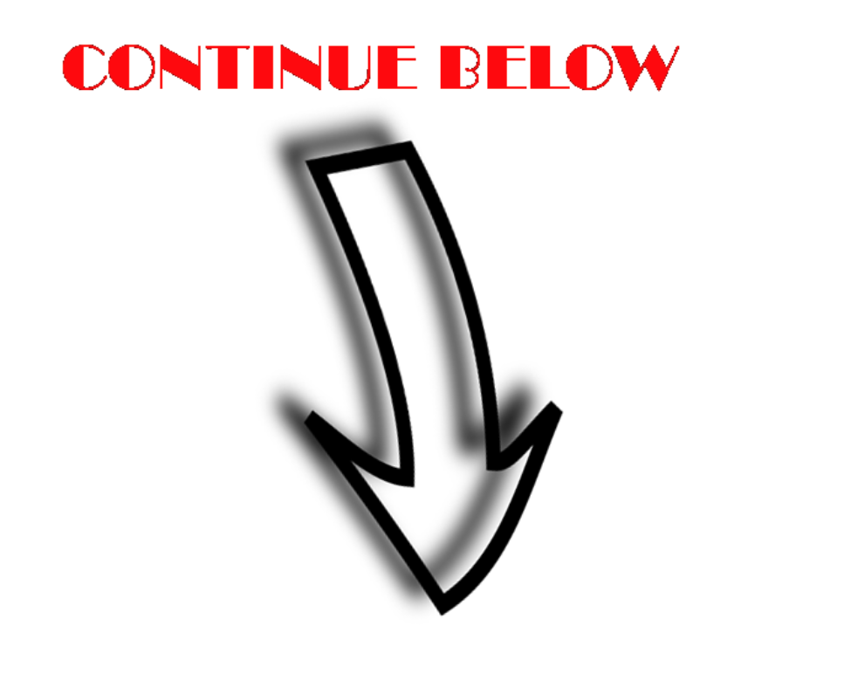
- 400 x 371
- Middle orientation
- Alt text: Continue below

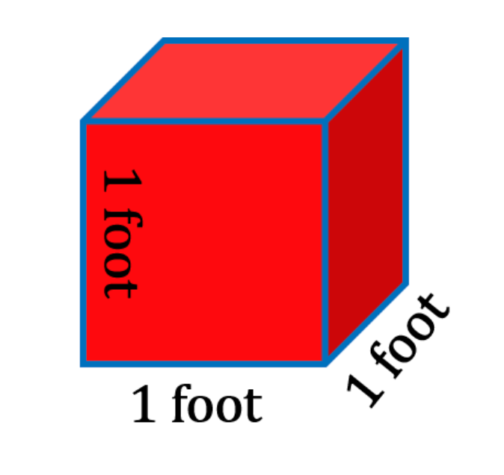
- 300 x 288
- Middle orientation
- Alt text: 1 foot by 1 foot by 1 foot cube.
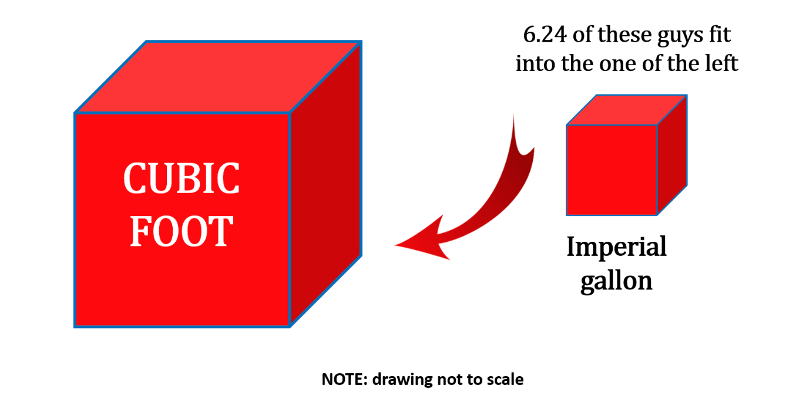
- 578 x 332
- Middle orientation
- Alt text: 6.24 imperial gallons fit in one cubic foot.
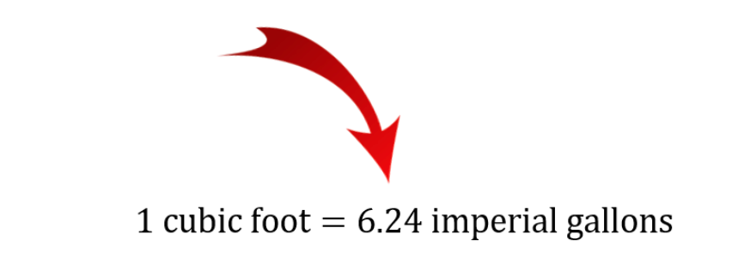
- 330 x 165
- Middle orientation
- Alt text: 1 cubic foot = 7.48 US gallons
- 360 x 51
- Middle orientation
- Alt text: Going from imperial gallon to cubic feet.

