Introduction to Consumer Behaviour Style Sheet
Last revised: June 23, 2021
House Style: BCcampus Open Education Publishing Style Guide
Author(s): Andrea Niosi (KPU)
Editor(s): Josie Gray and Kaitlyn Zheng

Book Structure
- This book has front matter, back matter, and then parts and chapters.
- Within each part, there are a number of chapters.
  - The first chapter is always “Key Terms and Concepts”
  - The last chapter is always “Chapter Reflections”

Part Structure
- Each part contains one Learning Objectives textbox (see textboxes)

Chapter Structure

Key Terms and Concepts
A shaded textbox that contains the following content:
- An H5P accordion activity.
  - The activity provides a list of all key terms and associated definitions used in the part in.
    - Terms are in alphabetical order.
    - Terms use sentence case.
    - The definitions are complete sentences that start with a capital and end with a period.
  - In the HTML, the H5P short code is contained within <div class=”h5p”></div> (This is so the H5P activity will only appear in the webbook)
- Following the H5P activity, the terms and definitions are provided as bulleted list.
  - In the HTML, the list of terms is wrapped within <div class=”pdf”></div> (This is so only the plain text version will appear in the export formats)
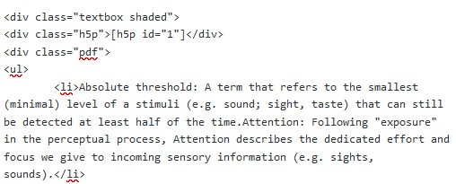

Chapter Reflections
- A blue textbox titled “Continue Learning” (See textboxes)

All Other Chapters
- End with a shaded textbox that includes the Media Attributions, Text Attributions, and References (in that order)

Custom Styles
The following is the Custom CSS used for this book. If you clone this book into your own instance of Pressbooks, you can copy this CSS in under Appearance > Custom Styles.

Web Styles
/*Bolds Heading 2*/
.front-matter h2, .part h2, .chapter h2, .back-matter h2, body#tinymce.wp-editor h2 {
font-weight: bold;
}
/*Bolds Heading 3s and left aligns them*/
.front-matter h3, .part h3, .chapter h3, .back-matter h3, body#tinymce.wp-editor h3 {
font-weight: bold;
text-align: left;
}
/*Fix table accessibility and display*/
.front-matter td, .part td, .chapter td, .back-matter td, body#tinymce.wp-editor td {
border: 1px solid;
border-color: #373d3f;
}
.front-matter th, .part th, .chapter th, .back-matter th, body#tinymce.wp-editor th {
border: 1px solid;
border-color: #373d3f;
}
#content table caption {
caption-side: top;
color:#000;
textalign: center; }
/*hide print equivalent of H5P*/
.pdf:not(body#tinymce.wp-editor .pdf){
display: none;
}

PDF Styles
/*Bolds Heading 2*/
.front-matter h2, .part h2, .chapter h2, .back-matter h2, body#tinymce.wp-editor h2 {
font-weight: bold;
}
/*Bolds Heading 3s and left aligns them*/
.front-matter h3, .part h3, .chapter h3, .back-matter h3, body#tinymce.wp-editor h3 {
font-weight: bold;
text-align: left;
}
/*Fix table accessibility and display*/
.front-matter td, .part td, .chapter td, .back-matter td, body#tinymce.wp-editor td {
border: 1px solid;
border-color: #373d3f;
}
.front-matter th, .part th, .chapter th, .back-matter th, body#tinymce.wp-editor th {
border: 1px solid;
border-color: #373d3f;
}
#content table caption {
caption-side: top;
color:#000;
text-align: center; }
/*Provide links in Print PDF, but not links that have class="internal"*/
.print a:not(.internal)::after {
content: " (" attr(href) ")";
}
/*Prevents textbox headings being on different pages from their content*/
.textbox__header {
page-break-after: avoid;
}
/*Change text alignment from justified to left-aligned (makes text more readable)*/
p {
text-align: left;
}
/*hide H5P error message when there's a print equivalant*/
.h5p:not(body#tinymce.wp-editor .h5p){
display: none;
}
/*remove empty footnotes in span tags */
span.footnote{
display: none;
}
/*reduce the margin after images*/
.front-matter .wp-caption.aligncenter, .part .wp-caption.aligncenter, .chapter .wp-caption.aligncenter, .back-matter .wp-caption.aligncenter, .front-matter .wp-nocaption.aligncenter, .part .wp-nocaption.aligncenter, .chapter .wp-nocaption.aligncenter, .back-matter .wp-nocaption.aligncenter {
margin: auto;
}
/*Makes it so centre/right/left-aligned images in the PDF without captions will have text wrap properly*/
img.alignright {
float: right;
margin-left: .5em;
}
img.alignleft {
float: left;
}
img.aligncenter {
display: block;
margin-left: auto;
margin-right: auto; }

eBook Styles
/*hide H5P error message when there's a print equivalant*/
.h5p:not(body#tinymce.wp-editor .h5p){
display: none;
}
/*Fix table accessibility/display*/
.front-matter td, .part td, .chapter td, .back-matter td, body#tinymce.wp-editor td {
border: 1px solid;
border-color: #373d3f;
}
.front-matter th, .part th, .chapter th, .back-matter th, body#tinymce.wp-editor th {
border: 1px solid;
border-color: #373d3f;
}
#content table caption {
caption-side: top;
color:#000;
text-align: center; }
/*Bolds Heading 2*/
.front-matter h2, .part h2, .chapter h2, .back-matter h2, body#tinymce.wp-editor h2 {
font-weight: bold;
}
/*Bolds Heading 3s and left aligns them*/
.front-matter h3, .part h3, .chapter h3, .back-matter h3, body#tinymce.wp-editor h3 {
font-weight: bold;
text-align: left;
}

Glossary
- Glossary terms are the terms that are listed in the “Key Terms and Concepts” chapters at the beginning of each part.
- Glossary terms are set up in the glossary tool and displayed automatically in the back matter “Glossary.”
- Glossary terms are bolded and marked as glossary terms the first time they are used in a part or chapter.
- Glossary definitions start with a capital and end with a period.

Headings and Capitalization
- Part and chapter titles: (Title case)
- Chapter headings start with H1 (Title case)
- Media Attributions, Text Attributions, References are H3 (Title case)

Numbering
- Parts and chapters are numbered automatically (Global Theme Options)

Textboxes

Continue Learning (Blue)
- A numbered list providing links to online resources.
- Each list item has at least one complete sentence with proper capitalizeation and punctuation.
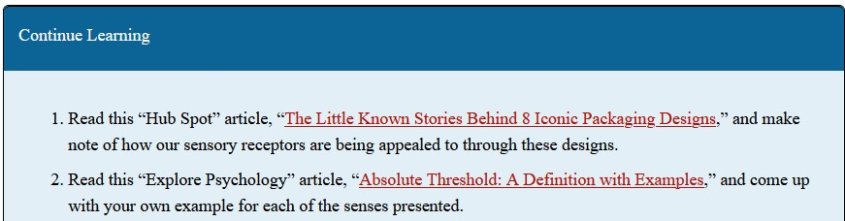

Learning Objectives (Black)
In this section, we will... [insert brief description.]
Upon completing this section, students should:
- Imperative statement that starts with a capital and ends with a period.
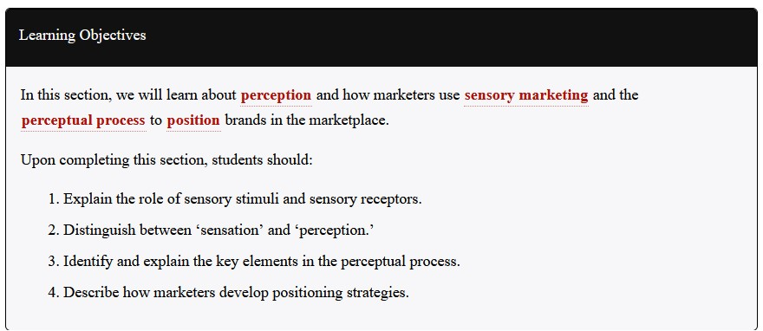

All Other Textboxes with Titles (Green)
- Used to provide examples or go more in depth into a topic.
- Titled to fit the subject, use title case

Shaded Textboxes
- Used at the end of each chapter to contain media attributions, text attributions, and references

