# Plumbing Level Four Series Style Sheet

Last revised: July 10, 2024

House Style: [BCcampus Open Education Publishing Style Guide](https://opentextbc.ca/publishingstyleguide/) - [Production Process](https://opentextbc.ca/publishingstyleguide/chapter/production-process/)

Author(s): Industry Training Authority

Editor(s): Arianna Cheveldave, Harper Friedman

Book links: [Block A](https://opentextbc.ca/plumbing4a/), [Block B](https://opentextbc.ca/plumbing4b/), [Block C](https://opentextbc.ca/plumbing4c/), [Block D](https://opentextbc.ca/plumbing4d/), [Block E](https://opentextbc.ca/plumbing4e/), [Block F](https://opentextbc.ca/plumbing4f/)

This style guide is based off the previous [Plumbing Apprenticeship Programming books](https://collection.bccampus.ca/search/?q=%22plumbing%20apprenticeship%20program%22) for the creation of the Plumbing Apprenticeship Program Level 4 books. In creating Plumbing Level 4 [Block B](https://opentextbc.ca/plumbing4b/) and [Block D](https://opentextbc.ca/plumbing4d/), we used this style sheet as well as the book [Plumbing Level 3 - Block D: Compressed Air Systems](https://opentextbc.ca/plumbing3d/) as a style reference.

Plumbing Level Four Series Style Sheet 1

Custom CSS 1

Apply House Styles 2

Lines around headers: 2

Book Structure 2

Parts 2

Chapters 2

Back Matter 2

Images 3

Media Attributions 4

Tables 4

Links 4

Numbering 4

Textboxes 5

Learning Objectives 5

Self-Test 5

Examples 6

Formulas 6

Large Numbers 7

Spelling consistency 7

Spelling to check out (add more if necessary) 7

Harper’s Process for Block B 7

## Custom CSS

### Apply House Styles

Go to the [Production Process chapter](https://opentextbc.ca/publishingstyleguide/chapter/production-process/) of the Publishing Style Guide and follow **Step 1. Apply Styles.**

### Lines around headers:

p[data-type="subtitle"]{

font-weight: bold;

font-family: 'Arial', sans-serif;

font-size: 1em;

border-bottom: 3px solid grey;

padding-bottom: 10px;

}

h1.entry-title {

border-top: 3px solid grey;

padding-top: 10px;

text-transform: uppercase;

}

## Book Structure

### Parts

* Title: Competency A#: Title of the Competency
  + Use title case, and CSS will transform it to All Caps.
* URL: 3-5 words from the subtitle
* Has a short (1-2 sentence) introductory statement.
* Contains a Learning Objectives textbox (see Textboxes).

### Chapters

* + Title: Learning Task #
  + Use title case, and CSS will transform it to All Caps.
* Subtitle:
  + Note that the subtitle is added to chapter metadata at the end of the page.
  + Use title case.
* URL: 3-5 words from the subtitle
* Headings
  + H1: Title case, the first heading in each chapter.
  + H2: Title case
  + H3: Sentence case
* Contains Learning Objectives at the beginning (see Textboxes).
* Contains a Self-Test at the end (see Textboxes).

### Back Matter

* Self-Test Answer Keys
  + H1: The name of the competency
  + H2: The name of the self test
  + Answers put in a numbered list and then add class=”threecolumn” to opening tag of list  
    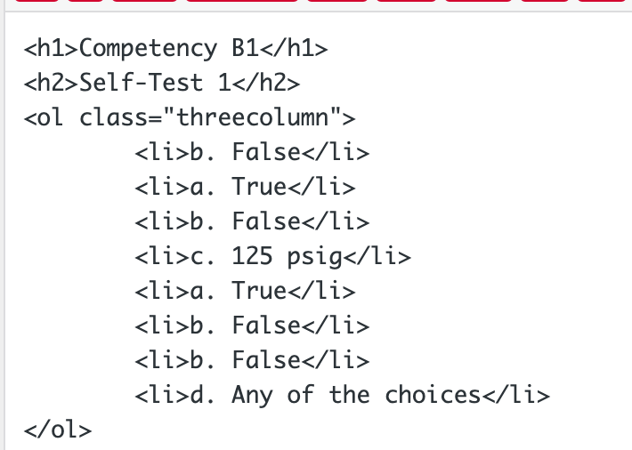
    - Answers should follow this format: #. [letter corresponding to multiple-choice answer]. [Answer] (see image below for example)

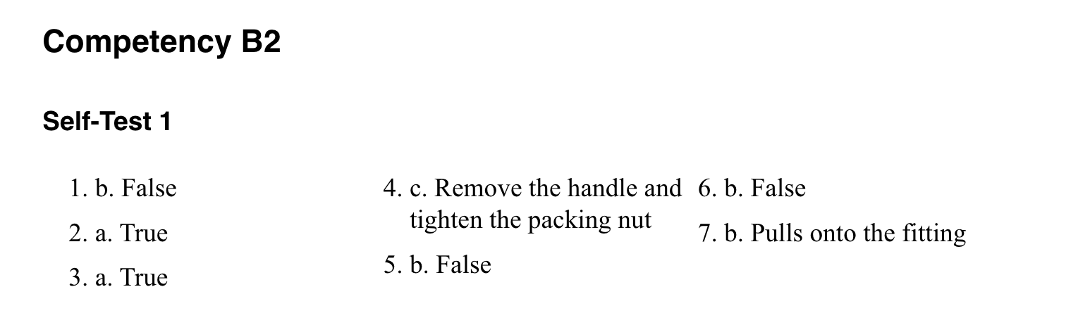

## Images

* Always centred.
* Pictures that don’t need to be seen with a lot of detail should have a width of 400 px.
* Pictures that are diagrams and have words should be inserted full size.
* For the checkbox icon used with self-tests, see Textboxes > Self-Test.
* Captions:
  + Figure #. Caption for the image.  
    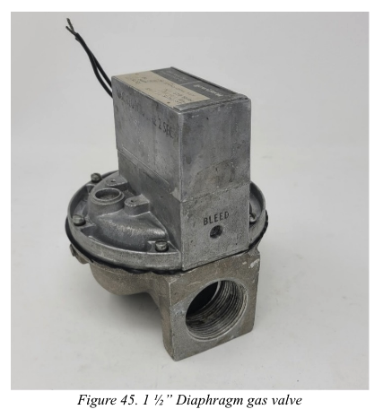
  + Numbering starts from 1 at the beginning of each learning task.
* Alt text – All images that convey information or are not already described in text need alt text. Make a list of those images here:

### Media Attributions

See the house style.

* Images by Camosun are CC BY.
* Images from BC Trades Modules are CC BY Trades Training BC
* Some images are used with permission – I am not sure how to attribute these yet, but they do have permission to use them.

## Tables

Follow accessibility best practices outlined in the [Tables chapter from the Accessibility Toolkit.](https://opentextbc.ca/accessibilitytoolkit/chapter/tables/)

## Links

Follow accessibility best practces outlined in the [Links chapter from the Accessibility Toolkit](https://opentextbc.ca/accessibilitytoolkit/chapter/links/).

## Numbering

* Parts and chapters
  + Each part is a new competency. Competencies are numbered as follows: A1, A2, A3, etc.
  + Each chapter is a new learning task. Learning tasks are numbered as follows: Learning Task 1, Learning Task 2, etc., with the numbering starting over for each competency.
* For image numbering, see Images > Captions.

## Textboxes

### Learning Objectives

* Inserted after the introductory statement at the beginning of each part (new competency)
* Title: “Learning Objectives”
* Intro sentence: “After completing the learning tasks in this competency, you will be able to:”
* Bulleted list starting with capital letters, not ending with a period.

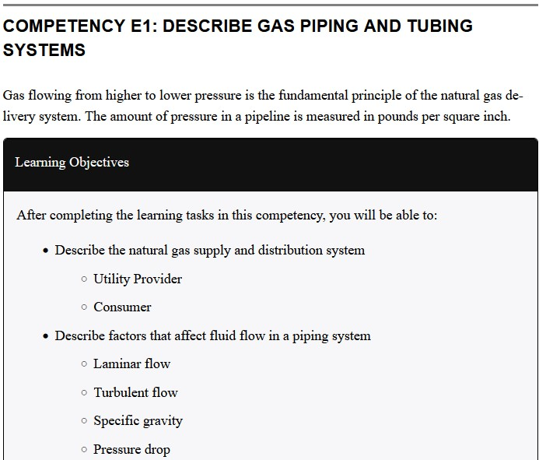

### Self-Test

* Each self-test textbox is preceded by the following:
  + A checkbox icon aligned left next to the following statement: Now complete A-1 LT1 Self-Test and check your answers.
    - The checkbox icon can be inserted from the media library with a width of 50px. The alt text should be left blank.
  + A heading 1: Self-Test #
* Title: Self-Test #
* Content: A properly formatted numbered list. For questions that are multiple choice, use type=”a” for the options.
* After the last question, insert the following statement: Check your answers using the [Self-Test Answer Keys](https://pressbooks.bccampus.ca/plumbing3e/back-matter/self-test-answer-keys/) in Appendix 1.

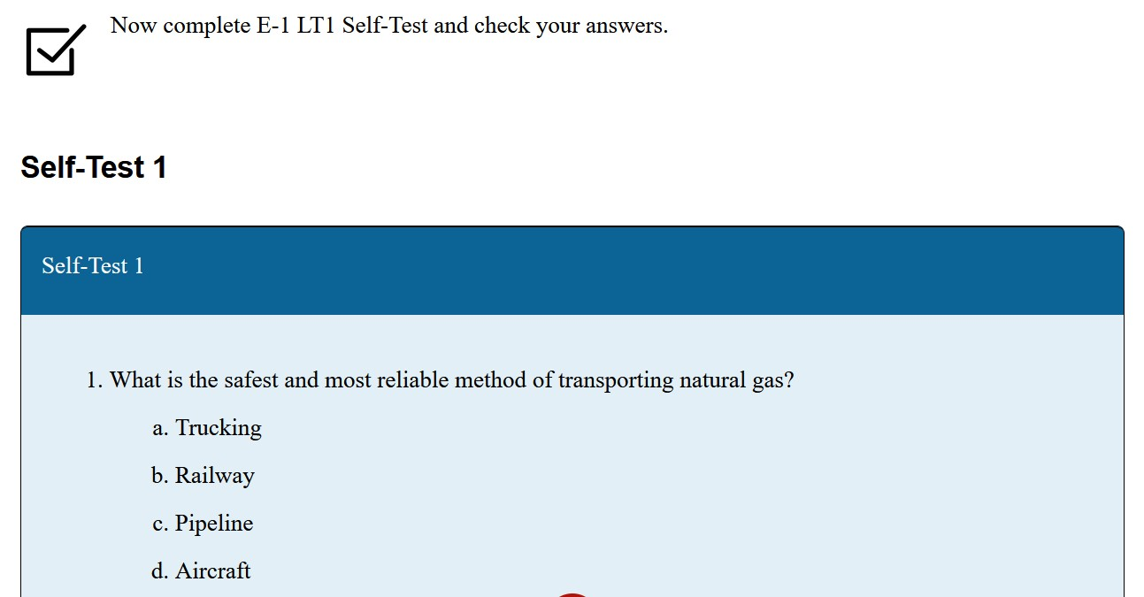

### Examples

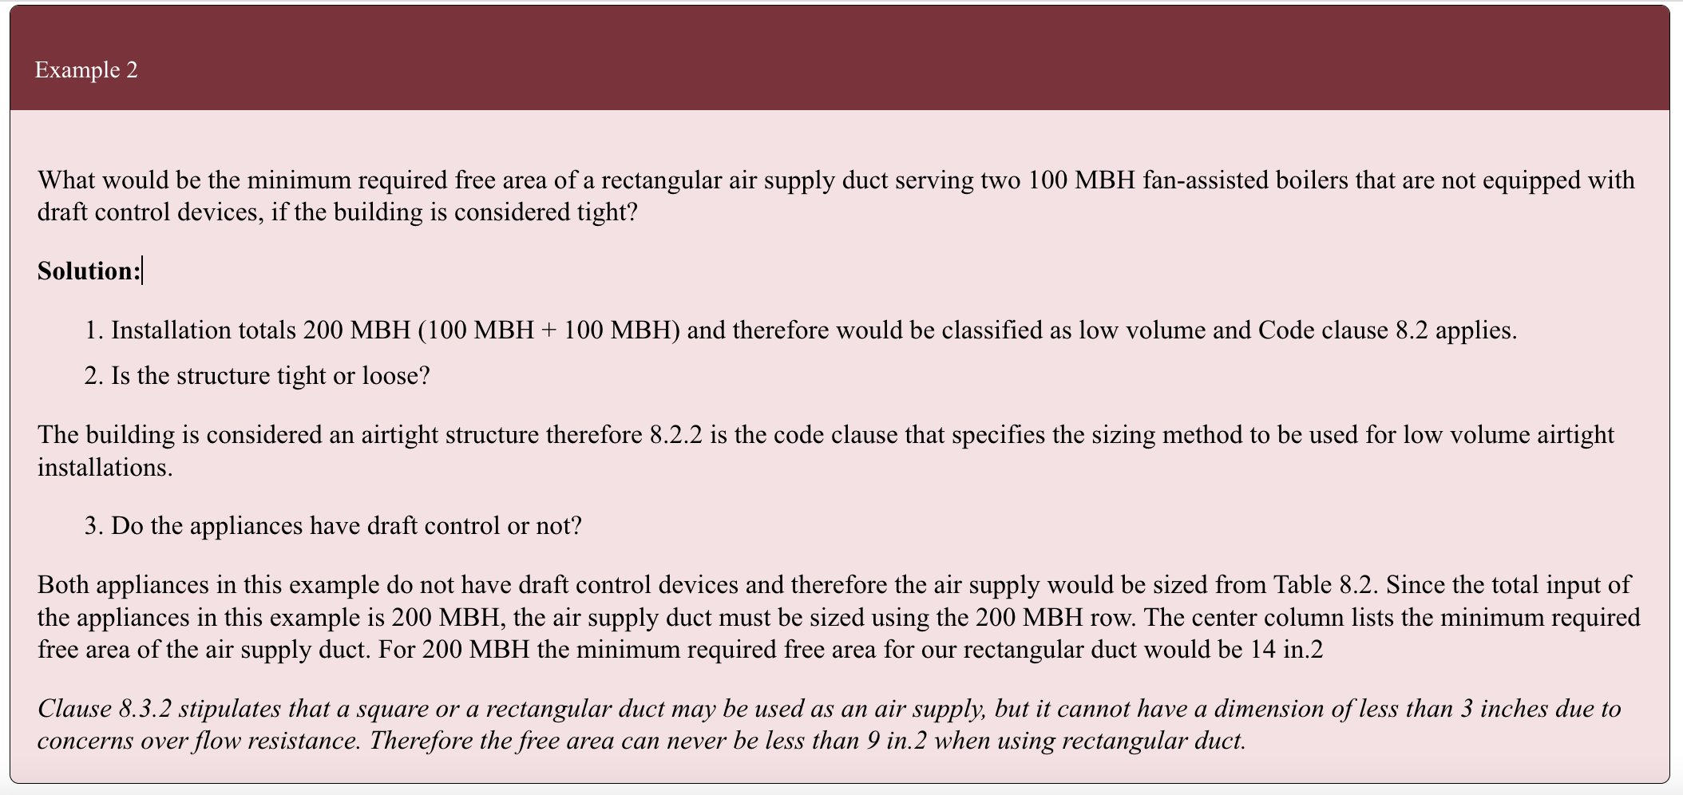

* Title: Example #
* Example text in paragraph font
* “Solution:” is bolded and in paragraph font
* Any paragraphs at the end that reference Clauses or Notes are italicized

## **Formulas**

* In LaTeX
* Centre-aligned
* To create spaces in large numbers, use “\;”  
  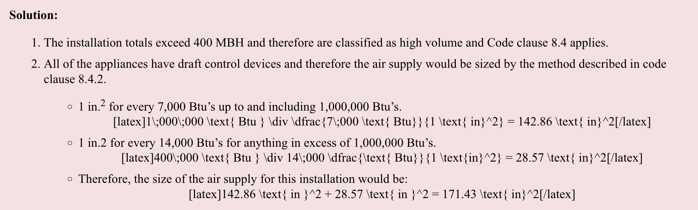

## Large Numbers

* If text numbers are 1000 and above, add a space for readability using HTML: <span style="margin-left: 0.25em;">###</span>
  + Example: To get 32 000, use 32<span style="margin-left: 0.25em;">000</span>
* Can use the followng regex command to find them: /(^|\s)(\d{1,3},*){4,}/

## Spelling consistency

* **“Grille”**, not “grill”
* **“in.2”,** not “in2”
* **“ft”,** not “Ft”, “Ft.”, or “ft.”

### Spelling to check out (add more if necessary)

* Pumpout, pump-out, pump out
* Fiberglass, fibreglass. COD says "fibreglass"
* Drainfield

## Harper’s Process for Block B

1. Created all necessary Parts and Chapters and titled them accordingly.
2. Downloaded all images from Word document
   1. Some figures required Grouping, as they were two images or had shapes and textboxes added. After I grouped them into one image, I downloaded them
   2. Labelled **Figure X - B#** (“B#” referring to the competency)
3. Uploaded all images into the Media Library on Pressbooks
   1. Important to keep labelling consistent and distinguish between Figures from different Learning Competencies
4. For each Learning Task (chapter):
   1. Copied the text for the entire Learning Task (minus Self-Test) into the Pressbooks Chapter
   2. Inserted images into the Chapter, then captioned, positioned, and sized them correctly
   3. Corrected Headings where necessary
   4. Created Self-Test heading and textbox, then copied the Self-Test into the textbox, fixing formatting when necessary
   5. Went through and fixed any consistency issues, wrote up LaTeX, and added span tags to large numbers
5. Formatted the Appendix 1: Self-Test Answer Key so that it matched the style of [Plumbing Level 3, Block D's Self-Test Answer Key](https://opentextbc.ca/plumbing3d/back-matter/self-test-answer-keys/) - with lowercase letters and the text answers written beside it.