Power Flower Activity
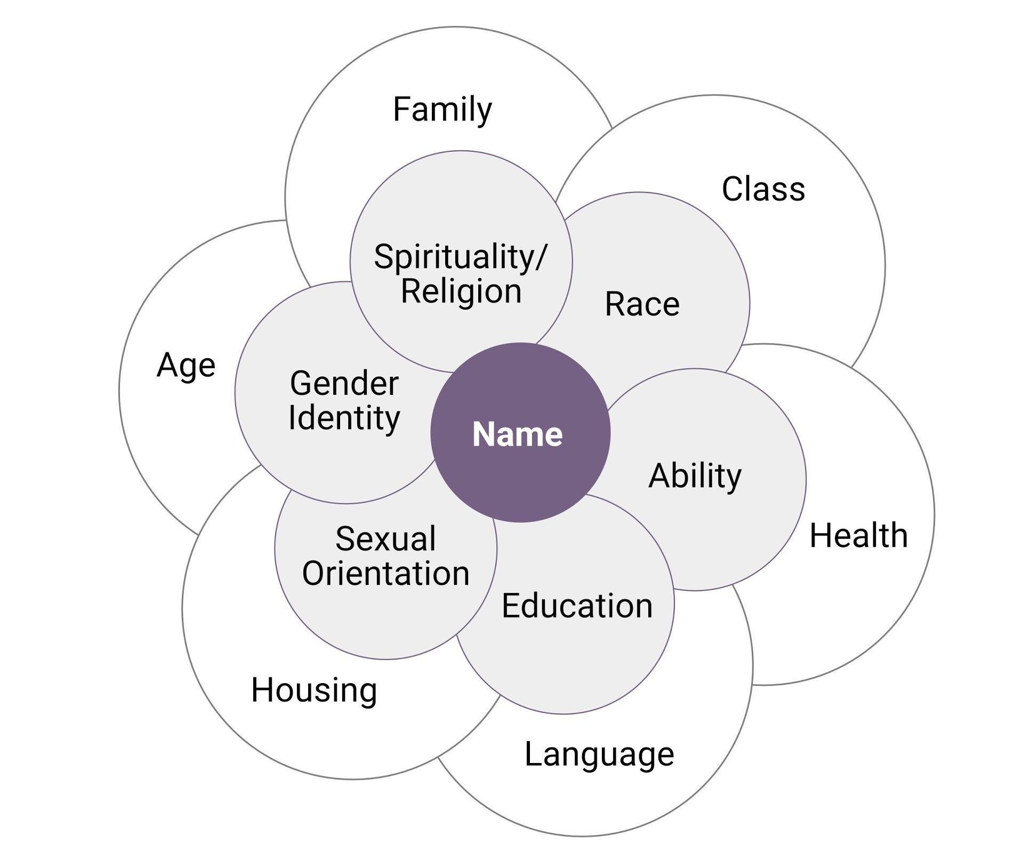
The Power Flower is a visual tool that we can use to explore how our multiple identities combine to create the person we are.
Instructions:
- Each person fills out their own power flower, identifying different aspects of their own identities in a number of categories. (Colourful markers or paper are always a bonus!). As we all have many identities, you may want to start with:
- Ethnicity
- Sex
- Gender identity
- Sexual Orientation
- Class
- Language
- Ability
- Family
- Education
Feel free to customize this list to your audience and the focus of your training.
- As a group, reflect on the implications of being able to choose certain aspects of your identity and not others and explore why you might think about certain aspects of your identity more than others. How does thinking through these different categories affect your perspective of yourself?
- What kind of power do you have? In your own life? As a student, staff or faculty member?
- What are your strengths? What are your skills? What kind of knowledge do you hold? What resources and supports are available to you?
- How might your power flower shape your experiences, knowledge, beliefs, and values about sexual violence?
Blank Power Flower
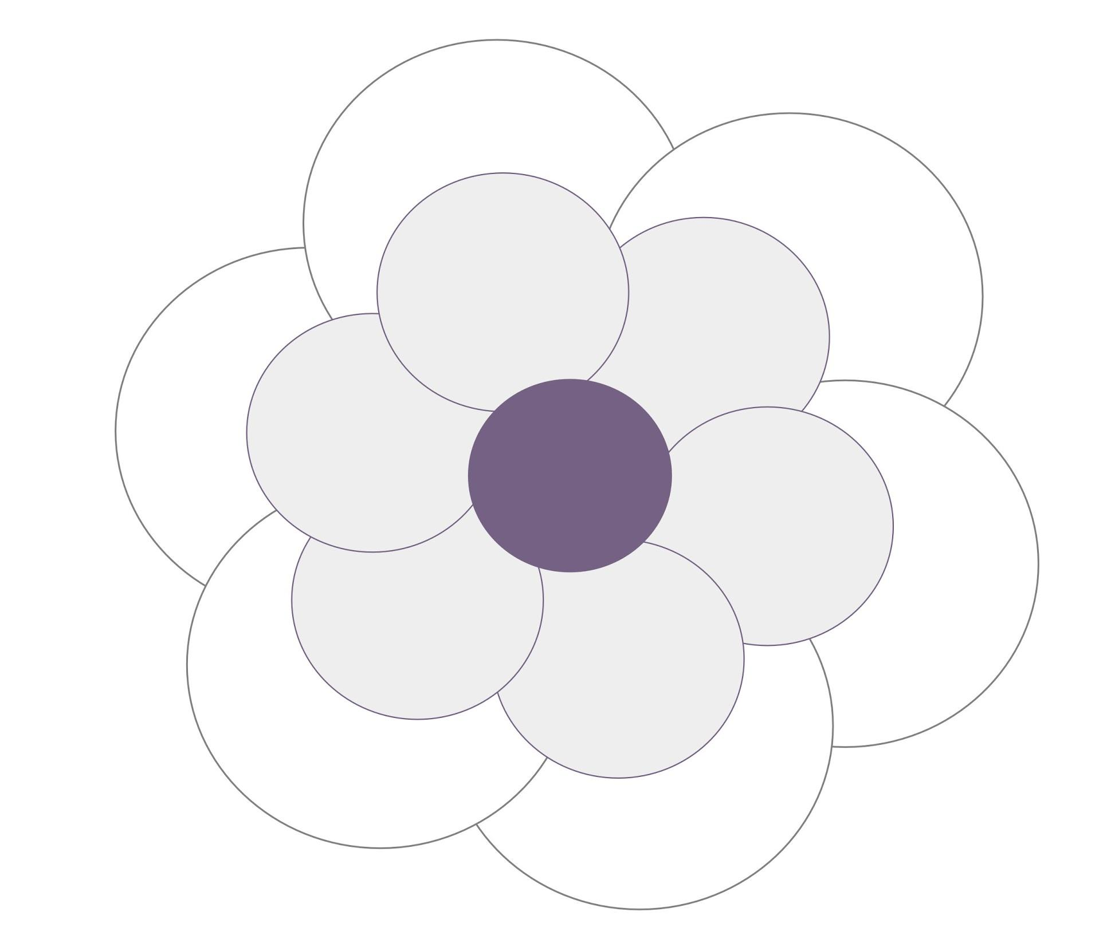

This resource is licensed under a Creative Commons license (CC BY 4.0 License) which means that you are free to share (copy, distribute, and transmit) and remix (adapt) this resource providing that you provide attribution to the original content creators. You can provide credit by using the attribution statement below.
Attribution statement:
Accountability & Repairing Relationships Training and Facilitator Guide: Preventing and Responding to Sexual Violence in BC Post-Secondary Institutions, Sexual Violence Training Development Team is licensed under a Creative Commons Attribution 4.0 International License, except where otherwise noted.
