Barriers to Disclosures Activities

When we talk about harm, many people wonder “Why didn’t they tell me in the moment?” or “Why didn’t they tell me sooner?” These activities are intended to help you explore some of the reasons why people don’t say they’re uncomfortable or talk about the harm they have experienced for a long time.

Part 1: Scenario Reflection

In the scenarios activity, we learned more about what people experience and how they respond in different types of situations. Reflecting on these scenarios, what do you think are some of the reasons why people don’t speak up or about what’s happened?

Part 2: “Why I Didn’t Report It” Image

Take a closer look at this image. What is this image about? What stands out for you? Who’s making those statements? Is there anything surprising that you hadn’t considered before? What would it take to overcome these barriers?
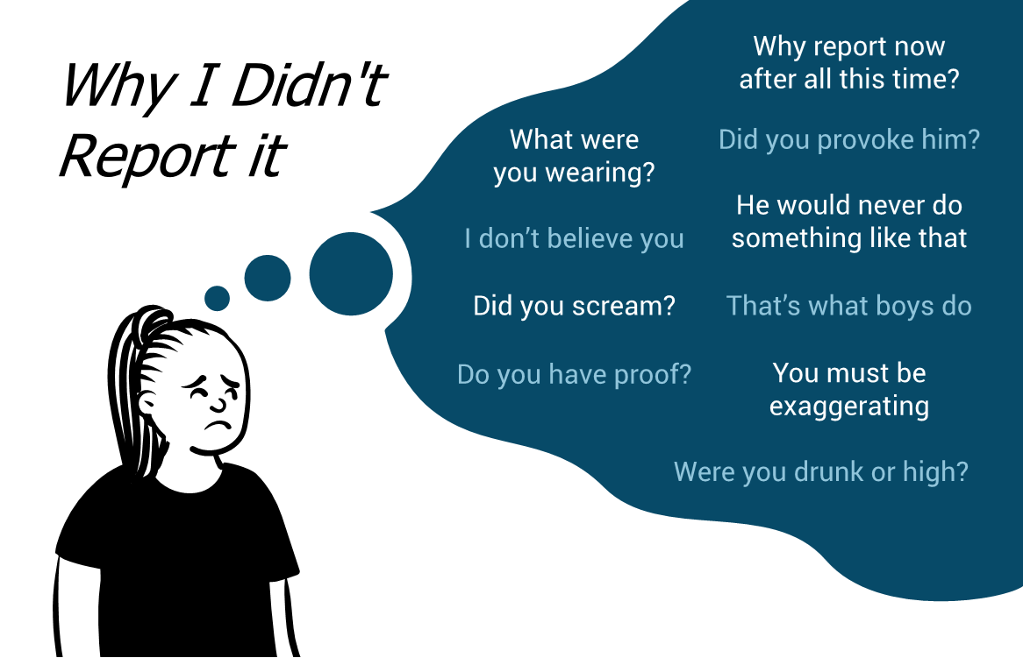

Part 3: Twitter Analysis

Search the #whyididntreport campaign on Twitter. Choose one or a few of the tweets that stand out to you as powerful or surprising. Write them here and bring them back for discussion.

____________________________________________________________________________
This resource is licensed under a Creative Commons license (CC BY 4.0 License) which means that you are free to share (copy, distribute, and transmit) and remix (adapt) this resource providing that you provide attribution to the original content creators. You can provide credit by using the attribution statement below.
Attribution statement:
Accountability & Repairing Relationships Training and Facilitator Guide: Preventing and Responding to Sexual Violence in BC Post-Secondary Institutions, Sexual Violence Training Development Team is licensed under a Creative Commons Attribution 4.0 International License, except where otherwise noted.
