Power and Privilege Wheel Activity

In each slice, identify which word fits you best. For example, on the “Wealth” slice, would you identify as “rich,” “middle class,” or “poor”? The closer you move to the center of the wheel, the more power you may experience as a community member.

Are they any surprises for you? What feelings come up for you? Are there any categories missing?
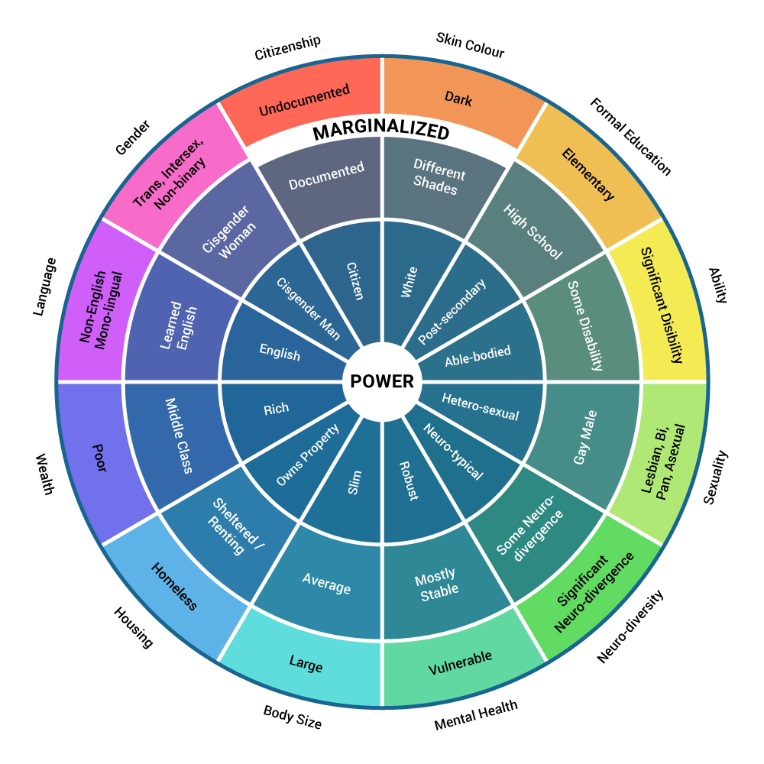

Image adapted from Sylvia Duckworth (2020).
This resource is licensed under a Creative Commons license (CC BY 4.0 License) which means that you are free to share (copy, distribute, and transmit) and remix (adapt) this resource providing that you provide attribution to the original content creators. You can provide credit by using the attribution statement below.
Attribution statement:
Accountability & Repairing Relationships Training and Facilitator Guide: Preventing and Responding to Sexual Violence in BC Post-Secondary Institutions, Sexual Violence Training Development Team is licensed under a Creative Commons Attribution 4.0 International License, except where otherwise noted.
