Your Support Circle

Seeking support from people that you trust can be helpful during and after this training. This activity can help you identify people and programs where you can seek support, including:
- Friends
- Family
- On-campus services such as counselling
- Community services and supports such as support groups or counselling services

Consider putting the people you trust the most or who are your strongest supports in the innermost circle. Update this circle with any new supports as you find them.
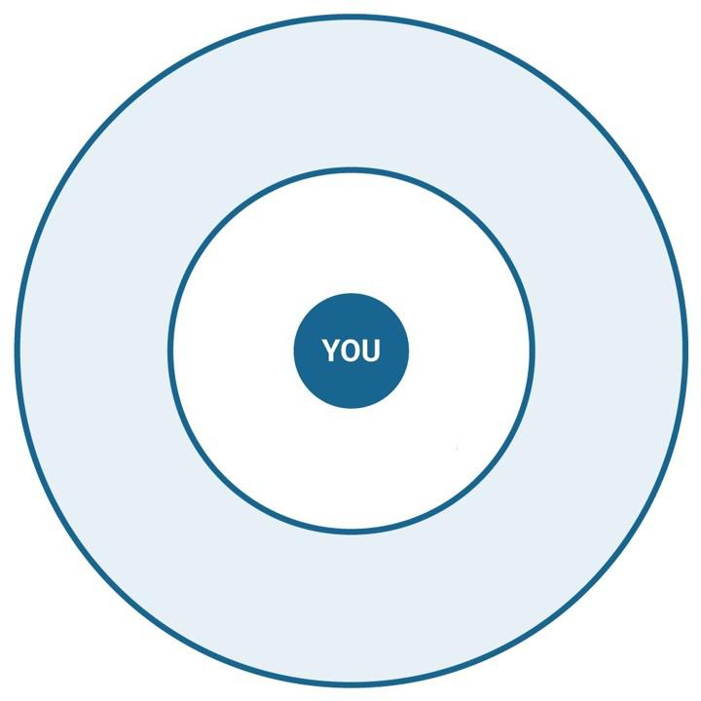
This resource is licensed under a Creative Commons license (CC BY 4.0 License) which means that you are free to share (copy, distribute, and transmit) and remix (adapt) this resource providing that you provide attribution to the original content creators. You can provide credit by using the attribution statement below.
Attribution statement:
Accountability & Repairing Relationships Training and Facilitator Guide: Preventing and Responding to Sexual Violence in BC Post-Secondary Institutions, Sexual Violence Training Development Team is licensed under a Creative Commons Attribution 4.0 International License, except where otherwise noted.

