Colonial Violence Wheel Activity
The Colonial Violence Wheel is a visual tool that can be used to help further discussion on the connections between colonial violence and sexual violence. Each section of the wheel provides examples of strategies, policies, and laws that have been enacted by the Canadian government to colonize and assimilate Indigenous people.
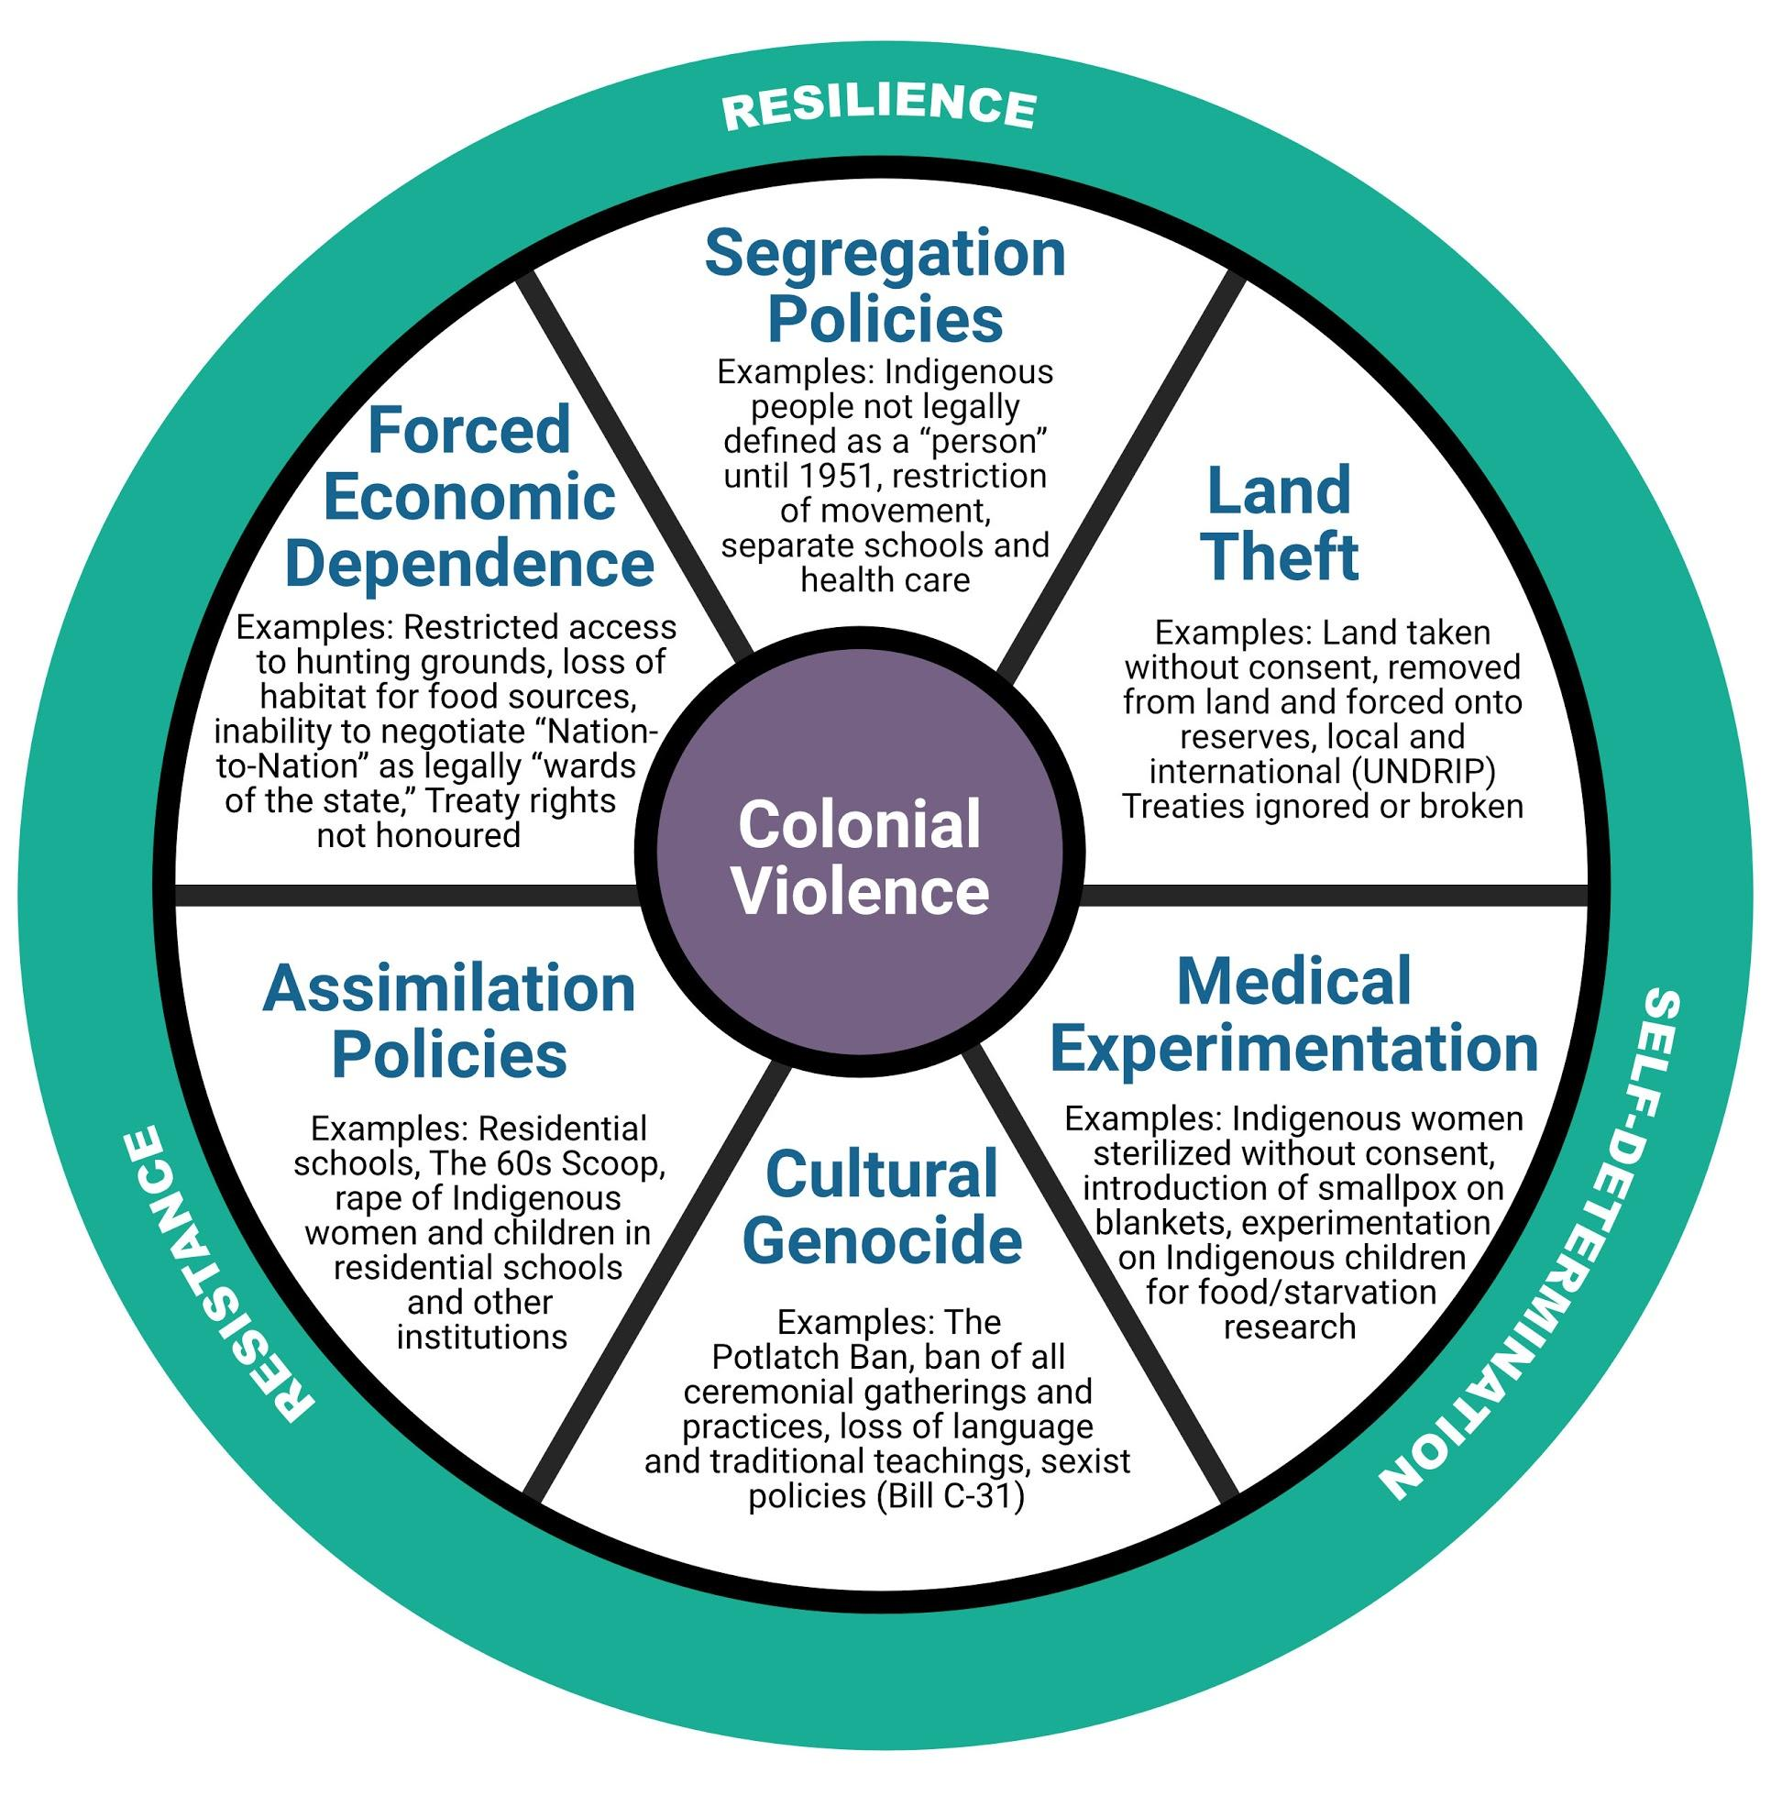
"Colonial Violence Wheel." Copyright, 2021, Jewell Gillies, Musgamgw Dzawada’enux. Used with permission under CC BY 4.0 License.

Discussion questions can include:
1. What do you already know about colonialism in Canada? What aspects of these strategies, policies and laws do you see in your life?
2. How do the strategies, policies, and laws described in the Wheel connect to sexism, racism, and other forms of discrimination?
3. How does colonial violence connect to sexual violence? For example, what is the connection between self-determination at an individual level (control of one’s own body) and at a community level (First Nations self-governance)?
____________________________________________________________________________

This resource is licensed under a Creative Commons license (CC BY 4.0 License) which means that you are free to share (copy, distribute, and transmit) and remix (adapt) this resource providing that you provide attribution to the original content creators. You can provide credit by using the attribution statement below.
Attribution statement:
Active Bystander Intervention Training and Facilitator Guide: Preventing and Responding to Sexual Violence in BC Post-Secondary Institutions, Sexual Violence Training Development Team is licensed under a Creative Commons Attribution 4.0 International License, except where otherwise noted.
