Plumbing Level Three Series Style Sheet
Last revised: February 4, 2022
House Style: BCcampus Open Education Publishing Style Guide
Author(s): Industry Training Authority
Editor(s): [Name]
(Add or remove headings as needed. Ensure to provide enough info that anyone can pick up and use the style sheet. You can use screen shots to illustrate examples.)

Book Structure

Parts
- Title: Competency A#: Subtitle of the Competency
  - Use title case, and CSS will transform it to All Caps.
- URL: 3-5 words from the subtitle
- Has a short (1-2 sentence) introductory statement.
- Contains a Learning Objectives textbox (see Textboxes).

Chapters
- Title: Learning Task #
  - Use title case, and CSS will transform it to All Caps.
- Subtitle:
  - Note that the subtitle is added to chapter metadata at the end of the page.
  - Use title case.
- URL: 3-5 words from the subtitle
- Headings
  - H1: Title case, the first heading in each chapter.
  - H2: Title case
  - H3: Sentence case (except for media attributions)
- Contains a Self-Test at the end (see Textboxes).

Back Matter
- Self-Test Answer Keys
  - H1: The name of the competency
  - H2: The name of the self test
  - Answers put in a numbered list and then add class=”threecolumn”

Images
- Always centred.
- Pictures that don’t need to be seen with a lot of detail should have a width of 400 px.
- Pictures that are diagrams and have words should be inserted full size.
- For the checkbox icon used with self-tests, see Textboxes > Self-Test.
- Captions:
  - Figure #. Caption for the image.
  - Numbering starts from 1 at the beginning of each learning task.
- Alt text – All images that convey information or are not already described in text need alt text. Make a list of those images here:

Media Attributions
See the house style.
- Images by Camosun are CC BY.
- Images from BC Trades Modules are CC BY Trades Training BC
- Some images are used with permission – I am not sure how to attribute these yet, but they do have permission to use them.

Numbering
- Parts and chapters
  - Each part is a new competency. Competencies are numbered as follows: A1, A2, A3, etc.
  - Each chapter is a new learning task. Learning tasks are numbered as follows: Learning Task 1, Learning Task 2, etc., with the numbering starting over for each competency.
- For image numbering, see Images > Captions.

Textboxes

Learning Objectives
- Inserted after the introductory statement at the beginning of each part (new competency)
- Title: “Learning Objectives”
- Intro sentence: “After completing the learning tasks in this competency, you will be able to:”
- Bulleted list starting with capital letters, not ending with a period.
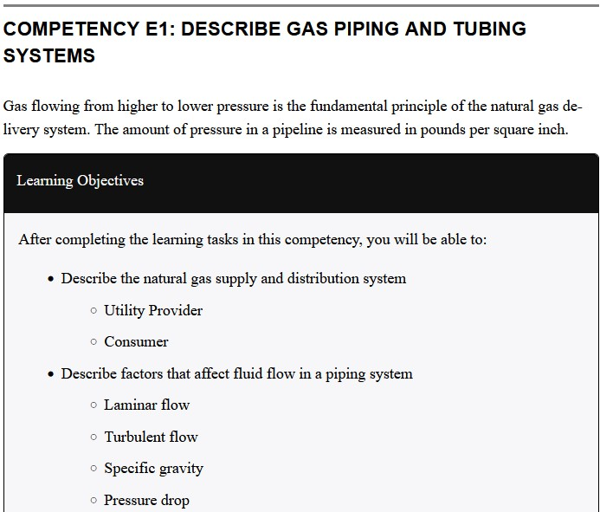

Self-Test
- Each self-test textbox is preceded by the following:
  - A checkbox icon aligned left next to the following statement: Now complete A-1 LT1 Self-Test and check your answers.
    - The checkbox icon can be inserted from the media library with a width of 50px. The alt text should be left blank.
  - A heading 1: Self-Test #
- Title: Self-Test #
- Content: A properly formatted numbered list. For questions that are multiple choice, use type=”a” for the options.
- After the last question, insert the following statement: Check your answers using the Self-Test Answer Keys in Appendix 1.
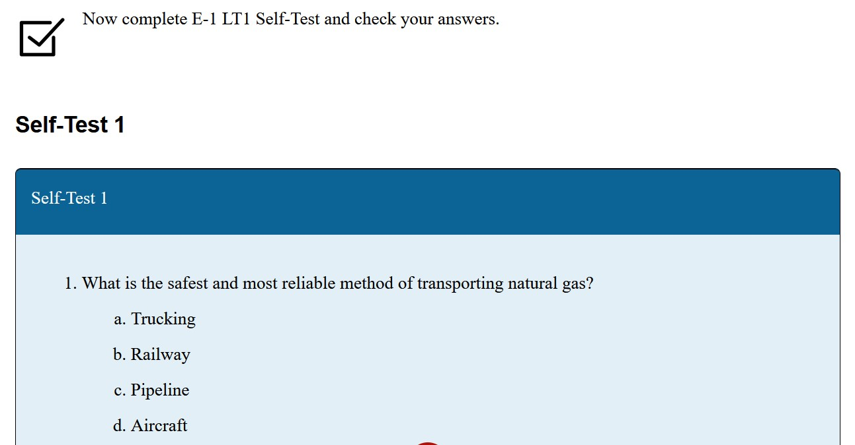

Formulas
- In LaTeX
- Centre-aligned

