Isolation Precautions Scenario
Elizabeth is a Health Care Assistant student completing her clinical rotation in a long-term care facility. She has been assigned two residents: Mrs. Kroeker, 68-year-old Filipino women with Type 2 diabetes, and Mrs. Gorski, a 75-year-old woman with rheumatoid arthritis.
During the morning report, Elizabeth learns that Mrs. Gorski has been put on droplet precautions since it is suspected that she has acquired severe respiratory distress syndrome. Nothing new was reported regarding Mrs. Kroeker.
Act 1
Elizabeth is at the doorway of Mrs. Kroeker’s room. She knocks.
Elizabeth: Good morning Mrs. Kroeker. It’s Elizabeth, your Health Care Assistant for today. May I come in?
Mrs. Kroeker: Come in.
Elizabeth enters the room. Mrs. Kroeker is sitting in a chair.
Elizabeth: I see you are up and ready for breakfast!
Mrs. Kroeker: Yes, I’m not feelings like eating breakfast this morning. (Pause) I had a bad night.
Elizabeth: But the night shift nurse reported that you had a good night.
Mrs. Kroeker: Not really. I’ve been to the bathroom a few times. I have diarrhea.
Elizabeth: Do you remember what time you were up?
Mrs. Kroeker: Around 3 I think, but I never look at the clock.
Elizabeth: Have you had any vomiting?
Mrs. Kroeker: No, just diarrhea. My stomach is off.
Elizabeth: Do you think you know what is causing this?
Mrs. Kroeker: I’m not sure but my son was here yesterday, and he said that his daughter had a flu. Maybe I caught it from him?
Question: What should Elizabeth say next?
- “Oh dear! I think maybe you caught the flu from your family!” (Incorrect. Feedback: As a Health Care Assistant student, Elizabeth should not jump to conclusions about a diagnosis.)
- “I don’t know if it’s the flu or something else. Maybe you have an E. coli infection.” (Incorrect. Feedback: As a Health Care Assistant student, Elizabeth should not jump to conclusions about a diagnosis.)
- “I will go get a thermometer and check your temperature.” (Incorrect. Feedback: Elizabeth should not independently decide on an intervention. This is beyond her role as a Health Care Assistant student.)
- “I’m going to let your nurse know how you are feeling, and she will probably want to take your temperature.” (Correct. Feedback: Check mark.)
Act 2
Elizabeth is in Mrs. Kroeker’s room, and Mrs. Kroeker is still sitting in a chair. Lucy, an LPN, comes into the room. Lucy cleans her hands with sanitizer that is positioned at the entrance to Mrs. Kroeker’s room (either mounted or sitting on a table by the door.)
Lucy: Good morning, Mrs. Kroeker. My name is Lucy and I’m your nurse today.
Elizabeth: Actually, Mrs. Kroeker was just talking to me about how she had diarrhea. She was up to the bathroom several times in the night. It started around 3 a.m.
Lucy: OK. When you were in the bathroom the last time, what did your stool look like?
Mrs. Kroeker: It was brown and watery.
Lucy: Did you notice any blood in the toilet?
Mrs. Kroeker: No, it’s just like mucous stuff.
Lucy: OK. Do you feel warm at all?
Mrs. Kroeker: A little.
Lucy: A little? Is it OK if I take your temperature?
Mrs. Kroeker: Sure.
Lucy gets a thermometer from a drawer in bedside table and takes Mrs. Kroeker’s tympanic temperature.
Lucy: Your temperature is 38.5 C. It’s a little warm, I am going to run and grab you some Tylenol, ok?
Mrs. Kroeker: Thank you.
Lucy leaves room.
Mrs. Kroeker: I think I need to go back to the washroom again. Do you think you can help me?
Elizabeth assists Mrs. Kroeker to stand and walks him to the washroom.
Elizabeth: Do you think you’re going to need any help in the washroom?
Mrs. Kroeker: No, I’m OK. Thank you!
Mrs. Kroeker closes the bathroom door.
Question: What should Elizabeth do next?
- Go to the supply room and get a sign that says, “contact isolation” and put this sign on Mrs. Kroeker’s door. (Incorrect. Feedback: Deciding on whether Mrs. Kroeker goes into isolation would not be an independent decision that Elizabeth should make. She should discuss this with Lucy first.)
- Stay close to the washroom. Make Mrs. Kroeker’s bed and tidy her room while waiting for her to come out. (Correct. Feedback: Check mark.)
- Find Lucy and inform her that Mrs. Kroeker is back in the washroom having more diarrhea. (Incorrect. Feedback: Elizabeth does not know if Mrs. Kroeker has more diarrhea or not, so reporting this is premature.)
- Go for her coffee break as Mrs. Kroeker will be in the washroom for a while. (Incorrect. Feedback: Mrs. Kroeker may feel weak when she finishes in the washroom and may need assistance, especially since she is likely dehydrated, and her blood sugar is probably low. It would be a safety concern to leave her alone at this time.)
Act 3
Elizabeth is making Mrs. Kroeker’s bed when Lucy comes to the room with a contact isolation sign in her hand.
Lucy: Elizabeth, I’m just going to put this contact isolation sign on Mrs. Kroeker’s door, OK?
Elizabeth: OK. Thanks for letting me know Lucy.
Lucy: You’re welcome
Lucy tapes the contact isolation sign to Mrs. Kroeker’s door and moves out of view. Mrs. Kroeker comes out of the washroom and sits back in his chair.
Elizabeth: Mrs. Kroeker, did you have any more diarrhea?
Mrs. Kroeker: Yes, I did. I think there is nothing left in there.
Elizabeth: You should try to drink some water, so you don’t become dehydrated.
Mrs. Kroeker: I’ll try.
Elizabeth: Do you want me to get you some Jell-O or broth?
Mrs. Kroeker: Oh, I’ll try some water.
Elizabeth: OK. [Short pause] The nurse has put that sign on your door that says, “contact isolation.” It’s just so people coming in know that you’re not feeling well.
Question: What else should Elizabeth say about contact isolation?
- “People coming into your room will be directed to wear masks and disposable gowns and to wash their hands frequently.” (Incorrect. Feedback: Show image of Contact Isolation sign.)
- “People coming into your room will be directed to wear gloves and a disposable gown and wash their hands when entering and exiting.” (Correct. Feedback: Check mark.)
- “Visitors will not be able to enter your room while you are feeling this way.” (Incorrect. Feedback: Show image of Contact Isolation sign.)
- “Contact isolation requires that you must stay in your room and not talk to anyone unless you are wearing a mask.” (Incorrect. Feedback: Show image of Contact Isolation sign.)

Act 4
Elizabeth is walking in the hallway and stops outside door of Mrs. Gorski’s room. The door to Mrs. Gorski’s room is open. There is a droplet precautions sign on the door. Mrs. Gorski is lying in her bed, on her back and slightly propped up with pillows.
Show a picture of the top half of sign (below) on the screen (everything above the section labelled “Staff.”
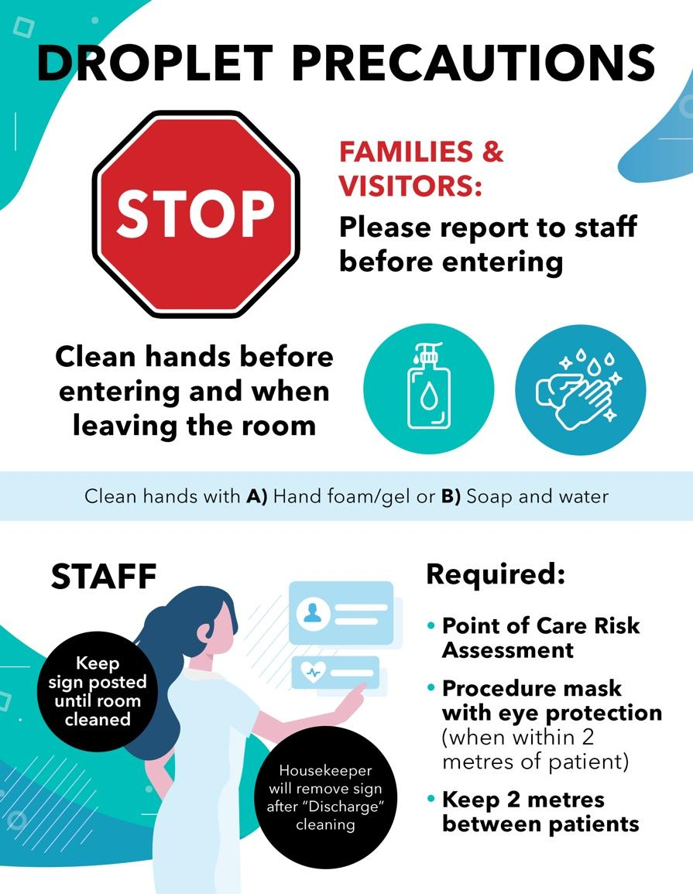

Elizabeth sanitizes her hands as she enters the room.
Elizabeth: Good morning, Mrs. Gorski.
Mrs. Gorski: Hi Elizabeth.
Elizabeth: I understand that you have not been feeling well. I have come to assist you with your morning care.

Mrs. Gorski: Oh, thank you. I feel a tightness in my chest, and I’ve been coughing a lot.
Elizabeth: Maybe you will feel a little better after I help you get freshened up.
Mrs. Gorski: Oh, that would be great. That would be really nice, thanks!
Question: Elizabeth goes to collect items needed for washing Mrs. Gorski. What PPE should she put on before interacting with Mrs. Gorski?
- Put on gloves. (Incorrect. Feedback: Show complete droplet precautions sign.)
- Put on a mask and protective eyewear. (Correct. Feedback: Check mark.)
- Put on gloves and a disposable gown. (Incorrect. Feedback: Show complete droplet precautions sign.)
- Put on a mask, gloves, and a disposable gown. (Incorrect. Feedback: Show complete droplet precautions sign.)
Act 5
Elizabeth is now leaving the washroom, wearing a mask and protective eyewear and holding a basin of water with a washcloth and a towel.
Elizabeth: OK Mrs. Gorski. I have everything set up here. (She twists out the washcloth). I’m just going to wring this out. Now here’s a nice little warm cloth.
Mrs. Gorski takes the washcloth and washes her face.
Mrs. Gorski: Thank you, Elizabeth. Oh, that’s nice and warm. (She wipes her face.) Ahhh, that feels so good Elizabeth. Thank you! [Pause] I think I soiled the bed. I had a little bit of diarrhea. It came on very suddenly. Usually, I’m able to get up to go to the bathroom but I just couldn’t make it. I’m sorry.
Elizabeth: That’s OK, Mrs. Gorski. I will get you cleaned up and you will feel better.
Mrs. Gorski: OK, thank you very much.
Question: Elizabeth finishes providing morning care and washes her hands before leaving Mrs. Gorski’s room. Then what should she do next?
- Change the droplet precautions sign to a droplet and contact precautions sign since Mrs. Gorski now has diarrhea. (Incorrect. Feedback: As a Health Care Assistant student, Elizabeth should not independently change the sign on the door. This would be the nurse’s decision once she knows of Mrs. Gorski’s new symptoms.)
- Ensure she closes Mrs. Gorski’s door so that visitors can’t enter Mrs. Gorski’s room. (Incorrect. Feedback: Keeping the door closed would not be necessary for droplet precautions, although it would be easier for others to see the sign before entering the room.)
- Report to Mrs. Gorski’s nurse that Mrs. Gorski had diarrhea during her morning care. (Correct. Feedback: Check mark.)
- Proceed to do morning care on her second client. (Incorrect. Feedback: Proceeding to her next client would not be the priority.)

